 Tunisian Republic Engineer of:   
 Ministry of High Education Electronics   
 And Scientific Research and Communications



University of Sfax Specialized in:



National School Embedded Systems

Of Electronics and Telecommunications of Sfax



REPORT

*Presented in*

National School of Electronics and Telecommunications of Sfax.

*To obtain*

The Engineer National Diploma in Electronics and Communication

*By*

Mohamed Baha Louati



IMU Based Prototypes



*Presented on . / .. / 2021, in front of the exam committee:*

|  |  |  |
| --- | --- | --- |
| Mr. | ….. | *President* |
| Ms. | Samir Ben Salem | *Academic supervisor* |
| Mr. | Mourad Fekhfakh | *Academic supervisor* |
| Mr. | Kharrat Mohammed | *Industrial supervisor* |

2020-2021



ACKNOWLEDGEMENTS



I would like to express my gratitude to all those in their presence, support, availability and advice I found courage to accomplish this project.

To Mr. Mohamed Kharrat

I will start by thanking Mr. Mohammed Kharrat, the Industrial supervisor who accompanied me since the start of this project, his kindness and cheerful spirit gave me precious encouragement, his precise and smart alternative solutions made things a lot easier and effective, he kept providing insight, guidance and trust which I am infinitely thankful for. I offer my sincere appreciation for the invaluable learning opportunities provided within his prestigious society.

To Mr. Mourad Fekhfakh and Mr. Samir ben Salem

My two Academic supervisors, Mr. Mourad Fekhfakh and Mr. Samir ben Salem, I cannot express enough thanks for both for believing and trusting in me, their understanding and support through all this project. My Heartfelt thanks.

To the teachers of the national Engineering school of Electronics and Telecommunication

I cannot complete this project without expressing my gratitude to all the teachers of the Enet’com for their guidance and assistance throughout our university course.

To the Committee members

Finally, I would like to thank the committee members who agreed to evaluate my work.



DEDICATION



It is with genuine gratitude and warm regard that, I dedicate this work to all those who are dear to me:

To my dear parents,

No dedication can express my respect, my never-ending love and me appreciation for the sacrifices you have made for my education and well-being.

I thank you so much for the prayers and support you have given me through the year and for instilling in me the virtues of perseverance and commitment me to work hard for the things that I aspire to achieve.

May this modest work be the fulfillment of your wishes so formulated, the fruit of your innumerable sacrifices.

May God, the Highest, grant your health, happiness and long life.

My dear family and friends,

To whom I am so grateful. Thank you for sharing with me all the happy and difficult moments, for enduring me during these months and especially for having always believed in me.



GENARAL INTRODUCTION



In the ever-growing world of sensors and microcontrollers, the ever-shrinking size presents new opportunities for innovative solutions: The processing power contained in a very small area complete with tiny devices with sensing capabilities pave the way to a new age of wearable electronics, a potential Market that the “CompiTechnology” the hosting Start-up is making innovations in.

in the first chapter called Project spectrum, the host company is presented, along with the Project objectives, constraints and time allocated for each task.

In the second Chapter, with a focus on improving human’s lives, we targeted stroke victims. a prototype to aid their rehabilitation. In it, we tested the possibility of using a prebuilt sensor fusion algorithm, for ease of development.

In the Third chapter, we study the capabilities of next project’s sensors as well as the microcontroller and also alternative development methods. this is a preparation for the manual sensor fusion possible integration in the next prototype.

is the fourth chapter, with a focus on Protecting human’s lives to begin with, we targeted possible drowning victims, a wearable drowning prevention prototype is created. This time, a manual sensor fusion algorithm will be implemented to fully exploit the provided resources.

This project has been a challenge for me yet a great opportunity to grow and exploit my academic background as an Electronic and Communication Engineering student and putting it into practical use to achieve the set targets.

SUMMURY

Chapter 1: Project Spectrum

1. Introduction 14

2. The Housing Start-up “CompiTechnology” 14

a. History: 14

b. Projects: 14

3. Project Objectives 15

4. Project scope: 15

5. Project Constraints 15

6. Time allocated 15

7. Work Methodology: 16

8. Conclusion: 17

Chapter 2 Physical rehabilitation aid module with Automatic sensor fusion.

1. Introduction 19

2. Stroke definition, types, effects and rehabilitation. 19

a. Definition of a stroke: 19

a. Types of strokes: 20

b. Effects of stroke: 21

c. Stroke Patients rehabilitation: 21

d. The Importance of Stroke Exercise 22

e. Interpretation: 23

3. Hardware Conception: 23

a. The BNO080: 23

i. Definition: 23

ii. Common problems with other IMUs: 24

b. Spark Fun Pro nRF52840 Mini - Bluetooth Development Board 25

4. Analysis and Conception: 26

a. Functional needs: 26

b. Non-functional needs: 27

c. Global Architecture: 27

d. Detailed Architecture: 28

i. The Initialization State: 29

ii. Bluetooth connection Establishment 31

iii. Data communication: 32

5. Implementation: 33

a. Hardware environment: 34

b. Software Environment: 35

i. Arduino: 35

ii. Unity3D 36

6. Hardware Connections: 38

7. Conclusion: 38

Chapter 3 In depth study for implementing manual sensor fusion in a drowning prevention prototype

1. Introduction 40

2. Problems with using an automatic sensor fusion: 40

3. Benefits of implementing our own sensor fusion algorithm: 41

4. In-depth Study of Hardware: 42

a. Inertial Measurement Unit: 43

i. Definition: 43

ii. Components: 43

1. Gyroscope: 43

2. Accelerometer 44

3. Magnetometer: 44

iii. The LSM9DS1 Inertial measurement unit: 45

b. SIM800L Module: 47

i. Introduction: 47

ii. Pinout: 48

iii. Architecture: 48

iv. AT commands 49

c. GPS NEO 6M Receiver 50

i. Introduction: 50

ii. NMEA Sentences: 51

iii. NMEA checksum: 52

d. MS5387 Pressure sensor 52

i. Introduction: 52

ii. Features 53

iii. Calculating Pressure: 54

e. Servo Motor: 55

i. Introduction: 55

ii. PWM motor control: 55

f. New IDE: Segger Embedded studio 56

g. Debugging Technology: J-link 57

h. J-Link RTT – Real Time Transfer 58

5. Conclusion: 59

Chapter 4 Drowning prevention prototype with Manual sensor fusion

1. Introduction: 61

2. Drowning: 61

a. Definition 61

b. Magnitude of the problem: 61

c. Active Solutions: 61

i. In-water and wearable on-person technology: 62

ii. Out-of-water technology 63

iii. Combined in-water and out-of-water technology 63

iv. Layers of protection 63

d. Future Preventative measures 63

e. Types of drowning: 63

i. Active Drowning: 63

1. Non-swimmer victims: 63

2. Swimmer victims 64

ii. Passive Drowning: 64

f. Instinctive Drowning Response 64

3. Interpretation: 65

4. Analysis and Conception: 66

a. Functional needs: 66

b. Non-functional needs: 66

c. Global architecture: 66

d. detailed Architecture: 68

i. User’s Input: 69

ii. Active Drowning detection 70

iii. Drowning Verification: 71

e. Use case diagram: 72

f. Sequence diagram: 74

5. Software environment: 76

a. Android studio 76

b. Processing: 77

c. Eagle 78

6. Hardware Connections: 79

7. Voltage Regulation 80

General Conclusion 81

List Of Abbreviations

IMU: Inertial Measurement unit

GPS: Global Positioning System

SMS: Short Message Service

[NMEA: National Marine Electronics Association](https://www.nmea.org/)

App: Application

BLE: Bluetooth Low Energy

SoC: System on Chip

OS: Operating System

GPU: Graphical Processing Unit

CPU: Central Processing Unit

RAM: Random Access Memory

UTC: Coordinated Universal Time

RTT: Real Time Transfer

DK: Development Kit

IDE: Integrated Development Environment

GPRS: General Packet Radio Service

EDA: Electronic design automation

PCB: Printed Circuit Board

XOR: Exclusive Or

LIST OF FIGURES

**Figure 1 CompiTechnology Logo** 14

Figure 2 V Cycle Technique 17

Figure 3 :World Health Organization Causes of death Statistic 20

Figure 4 : Main Types of Strokes 20

Figure 5: Effects of stroke on each brain lobe 21

Figure 6 Physical rehabilitation exercise 22

Figure 7 Architecture of the BNO080 24

Figure 8 The BNO080 Inertial Measurement Unit 24

Figure 9: Spark-fun nrf52840 pro mini 25

Figure 10 Global architecture 27

Figure 11 Composition of the Detailed Architecture 28

Figure 12The Initialization State Composition 29

Figure 13 Bluetooth Connection Establishment composition 30

Figure 14 Data Communication Composition 31

Figure 15 Arduino logo 34

Figure 16 Arduino Sketch in development 34

Figure 17 unity Logo 35

Figure 18 The humanoid replicating the user’s right-hand movement 35

Figure 19 Unity Software in Development 36

Figure 20 The Hardware connections of the prototype 37

Figure 21 Arduino Nano BLE 33 Pins 41

Figure 22 Sketch of the principle of operation of a MEMS gyroscope. 42

Figure 23 Sketch of the principle of operation of a MEMS accelerometer. 43

Figure 24 The Hall Effect principle 43

Figure 25 Location of the IMU in the Arduino Nano BLE 33 44

Figure 26 Mahony’s algorithm Block Diagram 45

Figure 27 Accelerometer, Gyroscope, Magnetometer Axis of LSM9DS1 45

Figure 28 Sim 800L pinout 46

Figure 29 SIM 800L Architecture 47

Figure 30 The GPS module NEO 6M 48

Figure 31GPS neo 6M Function Diagram 49

Figure 32 MS5837 Pressure sensor 51

Figure 33 Communication between the pressure sensor and the Microcontroller 52

Figure 34 Calculating pressure using the MS5837-02BA 53

Figure 35 The Servo Motor 54

Figure 36 Servo Motor Response 54

Figure 37 Segger Embedded Studio Environment 55

Figure 38 Debugging pins on Arduino BLE 33 and Nordic DK J-link 56

Figure 39 Debugging on Arduino BLE 33 56

Figure 40 Comparison between each debugging technology 57

Figure 41 Instinctive Drowning Response 64

Figure 42 Global Architecture 66

Figure 43 Detailed processes architecture. 67

Figure 44 Taking User’s Input 68

Figure 45 Starting active drowning Detection process 69

Figure 46 Drowning Verification Process 70

Figure 47 Drowning prevention prototype use case diagram 72

Figure 48 Sequence Diagram 73

Figure 49 APP Interface 75

Figure 50 Drowning prevention application on Android Studio 75

Figure 51 Processing sketch output showcasing a rotating 3D object 76

Figure 52 PCB designing in Eagle 77

Figure 53 Hardware Connections 78

Figure 54 the lm2596-ADJ switching regulator 79

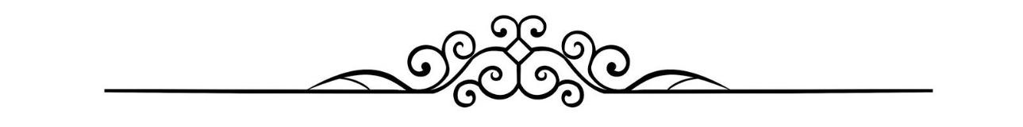

CHAPTER 1

PROJECT SPECTRUM

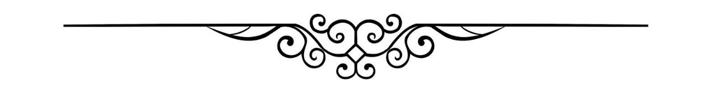

# Introduction

In this chapter we will start first with an introduction about the hosting institution, and then talk about the project objectives and the constraints we have, and we finish with the approximative time Allocated to finish each core part.

# The Housing Start-up “CompiTechnology”

Founded in April 2013, CompiTechnology is a start-up specialized in Design, implementation and test of high value-added devices. Based in Sfax, Tunisia, the company provides innovative and cost-effective solutions for its customers in several areas. The logo of the Enterprise is shown in the figure 1 below.

**Figure 1 CompiTechnology Logo**

# History:

“CompiTechnology” was founded in April 2013 in Tokyo, Japan by Doctor Mohamed KHARRAT. In 2014, the company was relocated to Sfax in order to take advantage of the abundance of skilled labor.

# Projects:

Many projects have been developed such as the "AYNA" application, it is a connected keychain used to locate keys or objects lost, and also the AKALA «your food advisor" mobile application, which analyzes the food components of products purchased in order to focus on healthy and better products. “HAYATEC” a portable oxygen Concentrator, with the goals of it being Deployed in Remote areas in harsh humidity and temperature conditions

# Project Objectives

The main objective of this project is to Take advantage of the ever-developing IMU technologies by designing working prototypes.

Those prototypes will soon be devolved into full projects with ever growing features, and support.

# Project scope:

this project covers the making of two IMU bases prototypes:

- a Physical rehabilitation aid prototype, aimed to patients who are suffering from movement impairment caused by strokes.

- And also, an Anti-drowning prototype, aimed to the general public, in an attempt to save the lives of wearers who might drown while swimming.

# Project Constraints

The project is constrained by these factors:

-Both objectives should be reached within the period of the internship

-The projects should reach at least a “proof of concept” stage, with the core functionalities achieved.

-each prototype has its own requirements.

-The prototypes should have the possibility be developed into ready to market products.

# Time allocated

Good planning is the most important element of a successful project, planning assists in the allocation of workload and the classification of the tasks that need to be done.

It enables more accurate estimation and management of the time needed for each part of our project.

Table 1 represents the approach we used to fulfill the multiple aspects of our project.

|  |  |  |  |  |  |  |  |  |  |  |
| --- | --- | --- | --- | --- | --- | --- | --- | --- | --- | --- |
|  | February | Mars | April | May | June | July | August | September | October | November |
| Documentation |  |  |  |  |  |  |  |  |  |  |
| Needs Analysis for projects |  |  |  |  |  |  |  |  |  |  |
| Embedded development: Prototype 1 |  |  |  |  |  |  |  |  |  |  |
| Mobile software Development: Prototype 1 |  |  |  |  |  |  |  |  |  |  |
| Embedded development: Prototype 2 |  |  |  |  |  |  |  |  |  |  |
| Mobile Software Development: Prototype 2: |  |  |  |  |  |  |  |  |  |  |
| Report Reduction |  |  |  |  |  |  |  |  |  |  |

Table 1: Time allocation for each task

# Work Methodology:

We chose the V cycle technique to plan and carry out our project.

This is a highly popular approach that was developed to address a number of concerns that were frequently faced in the cascade method.

The technical portion of this cycle is shaped like a V, beginning with the study of the product's business needs and functional specifications and finishing with the user's testing approval of the final product, as illustrated in the figure

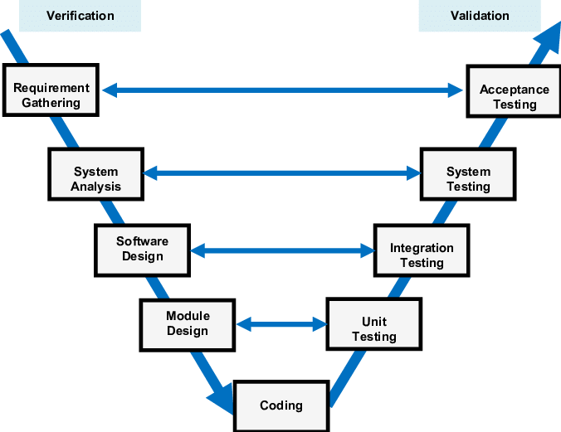

Figure 2 V Cycle Technique

# Conclusion:

In the first chapter we gave a brief presentation about the host organization, its field of activity and projects, we added also, our goals, explained the constraints and defined our work methodology. in the next chapter, we will talk about our first prototype, dedicated to stroke patients.



CHAPTER 2

Physical rehabilitation aid module with Automatic sensor fusion.



# Introduction

This chapter presents in it’s the first section an introduction to strokes, the types, the effects and the rehabilitation methods. A second section takes care of the analysis and conception of the prototype. a last third section is about the detailed creation of the solution using different software implementations and hardware connections.

# Stroke definition, types, effects and rehabilitation.

Strokes don't discriminate. A stroke can affect anyone, at any age. About one in four people worldwide will have a stroke in his or her lifetime [1], while every stroke isn’t lethal, it leaves people with impaired speech, restricted physical abilities, weakness or paralysis of limbs on one side of the body, difficulty gripping or holding things, and a slowed ability to communicate.

# Definition of a stroke:

Stroke is a condition that affects the arteries which go into and out of the brain.

Briefly, the brain is an extremely complex organ that controls various body functions. If a stroke occurs and blood flow can't reach the region that controls a particular body function, that part of the body won't work as it should.

A stroke occurs when a blood vessel that carries oxygen and nutrients to the brain is either blocked by a clot or bursts (or ruptures). When that happens, part of the brain cannot get the blood (and oxygen) it needs, so its brain cells die.

It is the Second leading cause of mortality in the world and a major cause of disability as shown in the figure below.



Figure 3 :World Health Organization Causes of death Statistic

# Types of strokes:

Stroke can be caused either by a clot obstructing the flow of blood to the brain This is called an ischemic stroke it can be temporary and its called a A TIA (transient ischemic attack), or "mini stroke".

a blood vessel rupturing and preventing blood flow to the brain called a hemorrhagic stroke, the two types are represented in the figure below.

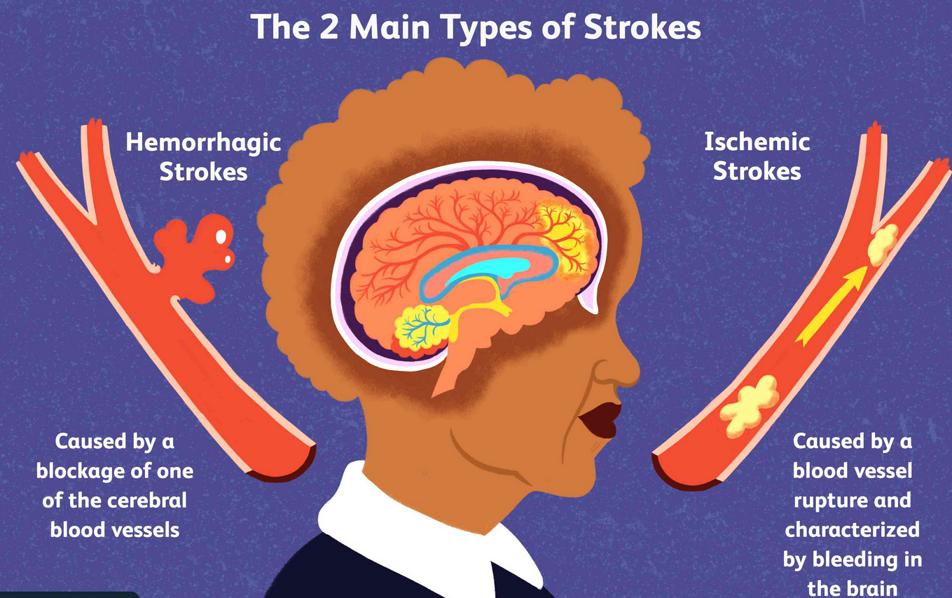

Figure 4 : Main Types of Strokes

# Effects of stroke:

If the stroke occurs toward the back of the brain, for instance, it's likely that some disability involving vision will result. The effects of a stroke depend primarily on the location of the obstruction and the extent of brain tissue affected.

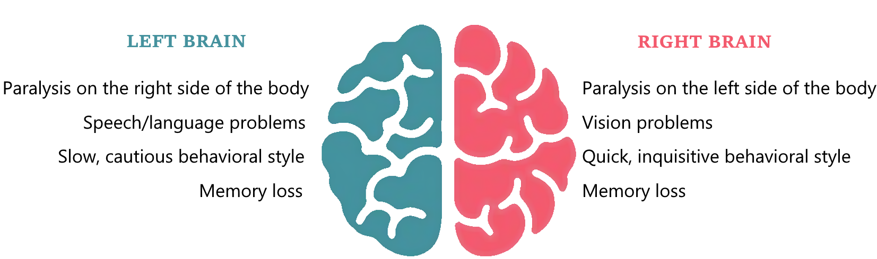The effects of a stroke depend on several factors, including the location of the obstruction and how much brain tissue is affected. However, because one side of the brain controls the opposite side of the body, a stroke affecting one side will result in neurological complications on the side of the body it affects, the effects of stroke on each side is shown in the figure below.

Figure 5: Effects of stroke on each brain lobe

# Stroke Patients rehabilitation:

Because strokes cause temporary or permanent damage to the brain regions that govern certain processes, stroke survivors may lose physical abilities, cognitive capabilities, and behavioral changes.

But there's good news: the brain can heal from a stroke, whether it happens right away or months or years later. While short-term (spontaneous) recovery after a stroke is restricted to the first six months, long-term functional recovery can happen at any time beyond that. Throughout their stroke journey, stroke survivors who continue to engage their afflicted side in everyday activities and exercise can maximize their functional recovery potential by:

• Motion (moving from bed to chair, walking, stair climbing, or using a wheelchair).

• Psychological health management to enhance coping abilities and, if necessary, treatment to overcome depression.

• boosting the Ability to communicate verbally and in writing.  
• Activities of daily living such as dining, showering, and clothing are assessed and improved in rehab programs.

• boosting Intellectual abilities which includes memorization and creative thinking.

• Interaction with those around, to boost social abilities

The rehab team meets once a week to evaluate performance, working on recovery is an important part of therapy. Another aspect is training to adjust to impairments that may not be completely recovered.

# The Importance of Stroke Exercise

Though its cells are destroyed, the brain is capable of restructuring and rebuilding itself. The healthy portions take up the functions that were previously performed by the damaged areas. Stroke patients can restore lost mobility and function because to a phenomenon known as neuroplasticity. The key to neuroplasticity is to do repetitive activities consistently so that the central nervous system can retrain how to do them through various brain connections.

Simply put, stroke exercise is one of the most effective ways for stroke victims to heal, strengthen, enhance their quality of life, and optimize their rehabilitation after stroke.

Because lifestyle conditions such as obesity and high blood pressure are major causes of stroke, physical activity becomes quite essential in reducing the chances of recurrent stroke and associated consequences.

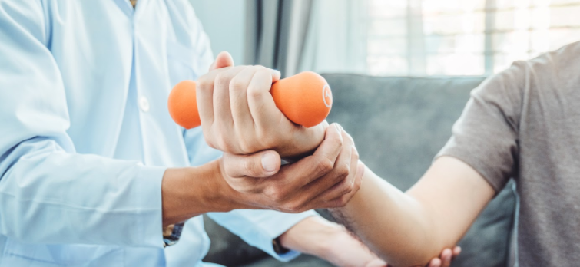Regardless of how severe the stroke was, victims can enhance the quality of life by adopting a healthier lifestyle and participating in rehabilitative activities. Whether you're making major or minor adjustments, the key is to stay focused. One of those adjustments is shown in the figure below.

Figure 6 Physical rehabilitation exercise

# Interpretation:

A stroke causes dramatic and unexpected changes in one's life, leaving individuals physically, socially, and emotionally fragile. Stroke rehabilitation, on the other hand, is the key to recovering one's body, brain, and quality of life.

There is a brighter future for patients if they persevere and strive effectively.

This is why we're working on a solution to assist those who have survived, and my role was to develop a prototype that tracks that motion and reproduce it on an external device.

This provides information to both clinicians and individual patients on their development, as well as making it easier to conduct future research in this subject.

# Hardware Conception:

For the hardware conception, we need a circuit able to detect motion, and communicate the data wirelessly via Bluetooth, therefore we had to pick an Initial measurement unit along with a development board with Bluetooth capabilities.

# The BNO080:

# Definition:

The BNO080 system’s motion sensor whose responsibility is the detection the changes in user’s motions.

The BNO080 is a System in Package that integrates a triaxial accelerometer, triaxial gyroscope, magnetometer and a 32-bit ARM® Cortex™-M0+ microcontroller running the SH-2 firmware, this firmware includes the Motion Engine™ software, which provides sophisticated signal processing algorithms to process sensor data and provide precise real-time 3D orientation, heading, calibrated acceleration and calibrated angular velocity, as well as more advanced contextual outputs like the accuracy and the precise refresh rate. The architecture of this device is shown in the figure.

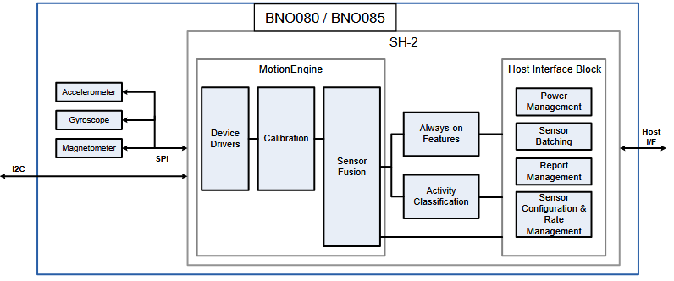

Figure 7 Architecture of the BNO080

# Common problems with other IMUs:

working with IMUs can be a challenge due to those common problems:

* The Manual Calibration of the sensor, introduces a human error factor, causing imprecision.
* Sensor’s aging and temperature play a role in adding more imprecise results.
* Different sensor fusion algorithms give varying results: while they can be reasonable, they’re not optimal.

Solutions offered by this IMU’s manufacturer:

* Sensors are factory-Calibrated.
* The Dynamic calibration of sensor data for temperature and aging
* The Implementation of a Custom sensor fusion algorithm offering the most optimal results.

This made the BNO080 a good candidate to be our Inertial Measurement Unit for this particular prototype, the BNO080 is presented in the figure below

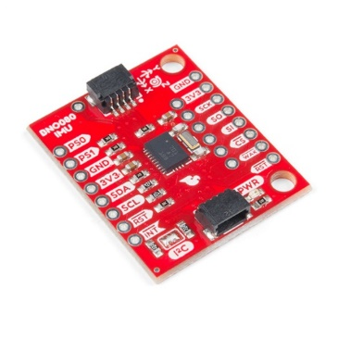

Figure 8 The BNO080 Inertial Measurement Unit

# Spark Fun Pro nRF52840 Mini - Bluetooth Development Board

We needed a development board with Bluetooth capabilities, as well as being able to be used wirelessly to be convenient during Testing, our pick was the Spark fun Pro NRF52840 mini which is shown in the figure

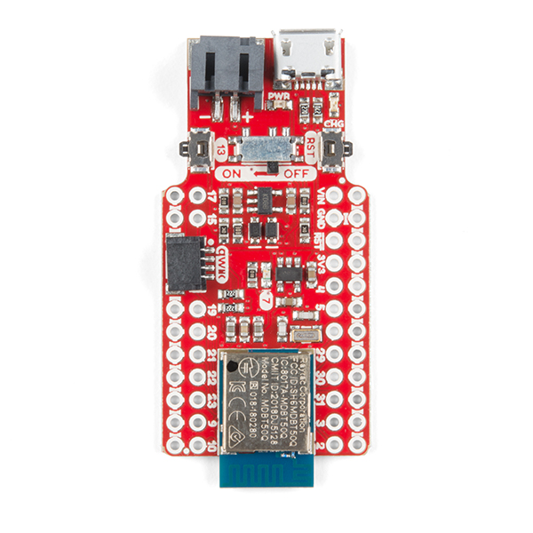

Figure 9: Spark-fun nrf52840 pro mini

It features a USB interface (using the nRF52840’s native USB support), which can be used to program, power, and communicate with the chip making it able to be used for any purpose (UART, I2C, SPI) that those of the Arduino Pro Mini could.

The Pro nRF52840 Mini features a Raytac MDBT50Q-P1M module. This module connects the nRF52840 to a trace antenna, fits the IC into an FCC-approved footprint, and also includes a lot of the decoupling and timing mechanisms that would otherwise be required for a bare nRF52840 design.

Also included onboard is a LiPo battery charger, a Qwiic connector, an on/off switch, a reset switch, and a user LED/button.

As previously mentioned, the Raytac MDBT50Q-P1M, contains an nRF52840 chip, it is basically the heart of our microcontroller, and the reason why the microcontroller is named this way.

The nRF52840 is built around the 32-bit ARM® Cortex™-M4 CPU with floating point unit running at 64 MHz

Exceptionally low energy consumption is achieved on nrf52840 chips using a sophisticated on-chip adaptive power management system.

It meets the challenges of sophisticated applications that need protocol concurrency and a rich and varied set of peripherals and features.  It offers generous memory availability for both Flash and RAM, which are prerequisites for such demanding applications.

The nRF52840 is fully multiprotocol capable with full protocol concurrency. It has protocol support for Bluetooth LE, Bluetooth mesh, Thread, Zigbee, 802.15.4, ANT and 2.4 GHz proprietary stacks.

# Analysis and Conception:

In this chapter, we start with a definition of our functional and non-function needs , then we design our architecture and explain all the core processes that need to be implemented .

# Functional needs:

-The detection of minor changes in the user’s movements

-The automatic connection with a smartphone to display the interpreted movement

Via Bluetooth low energy.

# Non-functional needs:

Performance: the prototype should report the limb’s measurements in Real time

Compatibility: the mobile app should be compatible with most devices

User -Friendliness: we should be aiming to make the prototype as easy to use as possible: The mobile device should handle Connecting and parsing the information without user intervention,

Physical restraints: The prototype should just have one single button, “On or OFF”, and broadcast Automatically when connected to a device: Having a single button gives us more flexibility and less physical restraints to work with.

Precision: The Data should be precise enough to capture the slightest improvement in the patient’s somehow slow motions.

Power-Efficient: the prototype is wireless therefore, to cause the least inconvenience: The prototype should last for several sessions without charging: power efficiency is key to achieve a desired result

# Global Architecture:

The general architecture of the device represents the main components and their relationship, its

The device is composed of two modules and the Smart phone , the general architecture is represented in the figure below, and further explained In the table ,

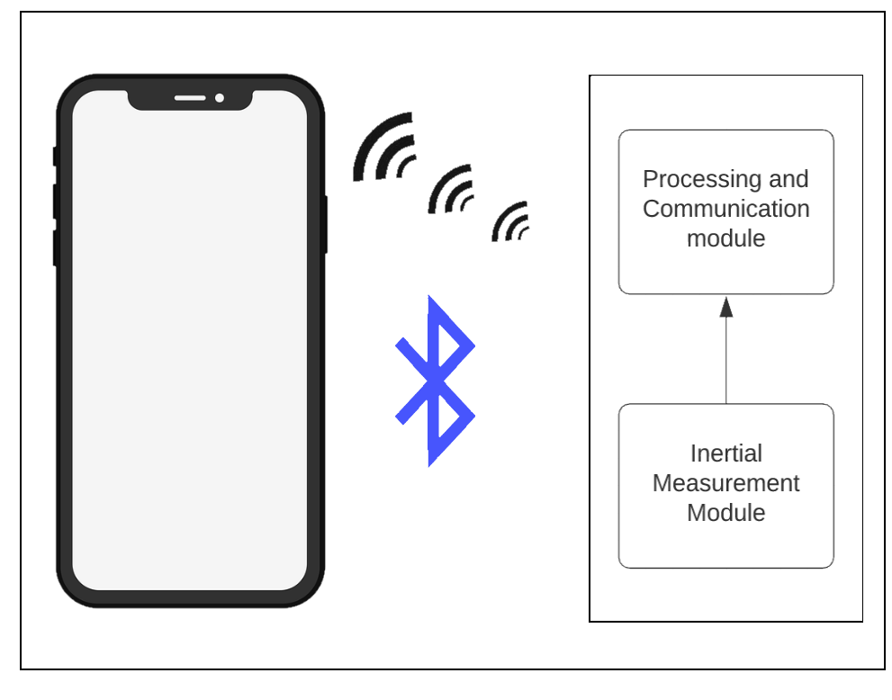

Figure 10 Global architecture

|  |  |  |
| --- | --- | --- |
| Module | Description | |
| Processing and communication module | | This module is responsible of the information processing, having the ability to communicate wireless via Bluetooth low energy to a mobile device as well as being able to process information coming from our inertial measurement unit and filter the desired results and send them in real time to be interpreted by the mobile device. |
| Inertial measurement unit module | | The unit is connected to the processing and communication module, the sensor provides information about the user’s motion in real time. |

Table 2: Description of the Global Architecture

# Detailed Architecture:

To further explain the function of our prototype, a detailed explanation is needed, we can subdivide our project into 3 distinct processes, Initialization, Bluetooth Connection establishment, and Finally the Device in its most important process: the Data Communication. we intend to further explain each process in a very detailed manner, leaving no ambiguities. The detailed architecture is presented in the figure called Composition of the Detailed Architecture.

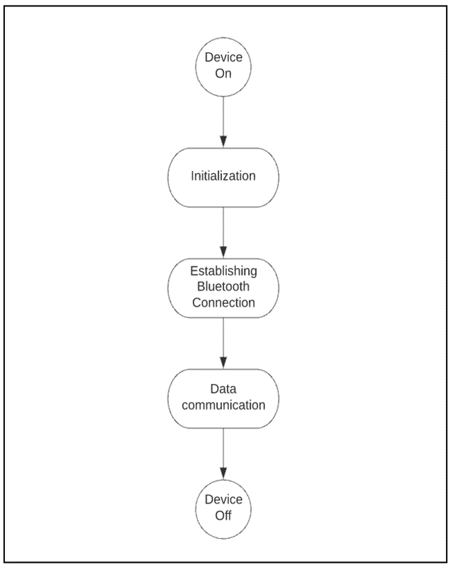

Figure 11 Composition of the Detailed Architecture

# The Initialization State:

The initialization state is the first state, in it, the communication protocols are configured and the sensor is calibrated. this is the infrastructure of our prototype, defining the settings of the

communication between the sensor to the microcontroller. The components of this state are showing in the figure, and explained in the table.

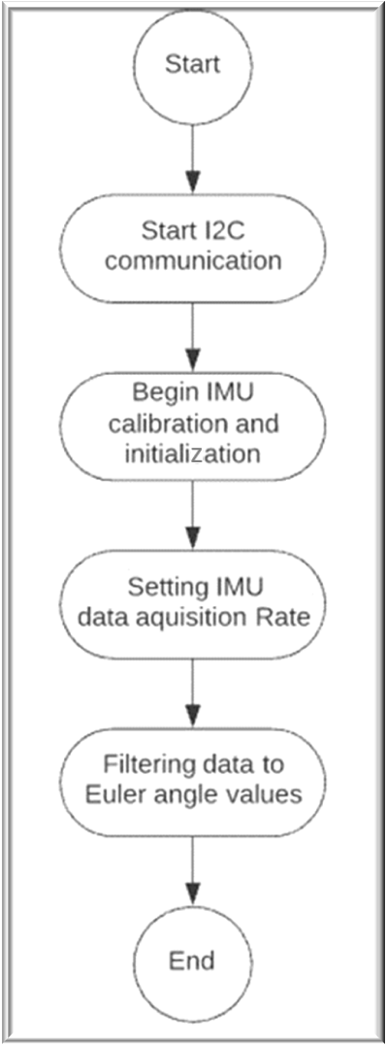

Figure 12The Initialization State Composition

|  |  |
| --- | --- |
| Process | Description |
| Starting I2C communication | The device starts by enabling I2C communication protocol, this protocol communicates with the IMU.  This protocol communication speed varies between 100 KHZ in standard mode and 400KHZ in fast mode: We picked 100Khz Transfer Speed for this prototype.  in this communication protocol, the faster the speed, the lower the reliability especially with long wires. |
| Begin IMU Calibration and Initialization | Beginning the IMU calibration and Initialization process is a process where the microcontroller communicates with the IMU, Requesting the start for the sensors as well as handling the calibration. This process doesn’t take more than a second and is necessary for The IMU function. |
| IMU data acquisition rate setting Process. | In this Process, we pick the Refresh rate of our IMU readings, various speeds can be picked, Higher speed offers more fluidity in the application at the cost of more energy consumption.  Most of the Energy Consumption is due to the Bluetooth low energy notification Rate as well as the IMU sensor's Reading and processing rate.  We picked 10Hz because it offered a responsive experience. |
| Filtering Data process | The data Received by the I2C protocol might contain more information than needed, for example, the Accuracy of the data as well as the Refresh rate of the sensor, this data is filtered to Yaw, Pitch, Raw Values only which are the only values we need to be sent to interpret the movement in 3D space. |

Table 3: The Initialization State Description

# Bluetooth connection Establishment

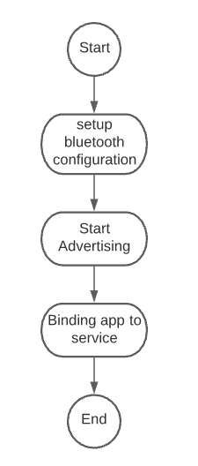The Bluetooth Connection is a core functionality of our prototype, the core components are presented in the figure. its correct configuration and establishment must be well defined, this is documented in the table.

Figure 13 Bluetooth Connection Establishment composition

|  |  |
| --- | --- |
| Setup Bluetooth Configuration | Setting the Bluetooth device name: We pick “Nordic '' as our Device Name. This name will be used to identify our prototype by the smartphone application  Setting Callbacks: Bluetooth callback functions are used in a handler to identify Bluetooth connection and disconnection states.  - Bluetooth Service Setup: We picked a Bluetooth Service with a Notification Property, and 12 bytes of Data as a fixed Data length. We are sending 3 floats representing Yaw, Pitch, And Roll, in the IEEE float standard, each float is 4 bytes of data |
| Advertising Process | After we finish configuring our Bluetooth device we start the advertising process, the advertising process typically lasts 30 seconds, with 20 Millisecond interval between each advertisement, this is standard in Bluetooth devices, this process should also restart when the connected device is disconnected, this should be implemented to avoid switching the prototype “on” and “off “in case of losing connection. |
| Binding the Mobile app to the Bluetooth Service | When the Bluetooth Communication is established, the device Starts notifying the smart phone with the Yaw, Pitch and Raw values, the Bluetooth service we created is now bound to the application. |

Table 4: Description of Bluetooth connection establishment.

# Data communication:

This state is the most important state for this module, this is where the communication between the mobile app and the embedded system is occurring it stays on repeat until either the user turns off the module or the battery runs out.

This step is better explained if we split this communication into two sides, each side is executing their own processes, and waiting for the other side to finish theirs.

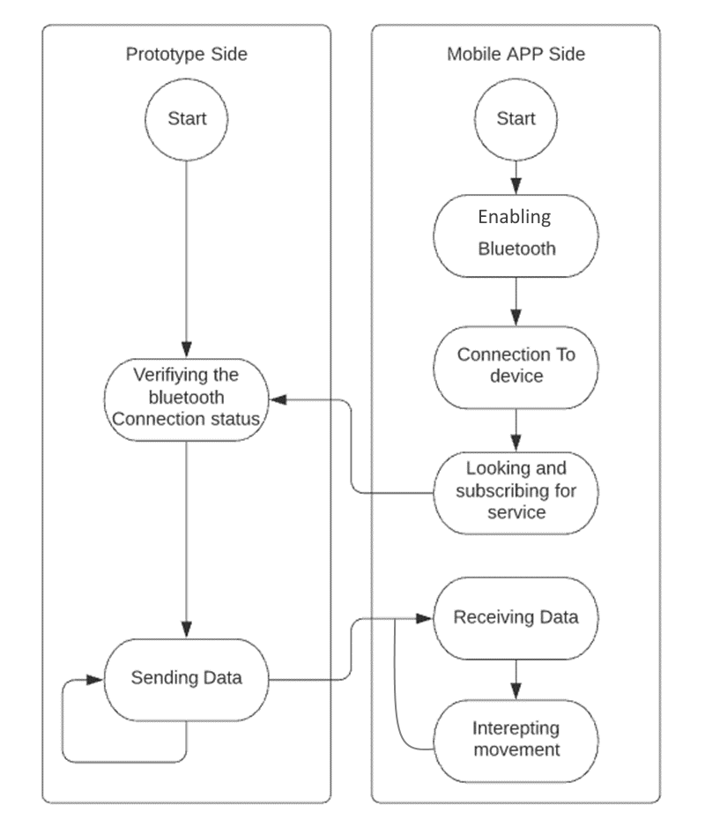as done in previous states, we will explain this step in more detail. In the figure blow and the accompanied table.

Figure 14 Data Communication Composition

|  |  |
| --- | --- |
| Process | Description |
| Enabling Bluetooth | Mobile app sided: the smartphone should have Bluetooth enabled, if its not, an error is shown on the screen and the user needs to enable Bluetooth and restart the application |
| Connection to the Device | Mobile app sided: Once the application starts, it automatically searches for Bluetooth devices with the Name “Nordic” |
| Looking And subscribing for service | Mobile app sided: After being connected to the device Via Bluetooth, the Mobile app should be able to detect the Bluetooth Services present, and then automatically subscribe to our motion notification custom Service. |
| Verifying connection status | Prototype Sided: Before Sending data, the prototype verifies if the its connected to the mobile app. |
| Sending Data | Prototype Sided: As long the smart phone is connected to the device, this step should be on loop. |
| Receiving Data | Mobile app sided: Data reception and parsing is handled with this process |
| Interpreting movement | Mobile app sided: The received data should be interpreted as movement on the humanoid figure |

Table 5: Data communication Composition

# Implementation

Since The architecture design is now complete and clear,

We now have an unambiguous idea of how our project should behave, The Implementation stage is the next, its where They are used to test the functionalities of the design or just for making sure that it is possible to create that kind of design.

This is a critical stage in ensuring that our prototype is ready.

In the next paragraphs, we will first describe the working environment and technologies that were used to complete this project.

And after that we show how the components are connected in the hardware connections sections

# Hardware environment:

To do the required tasks, we used a laptop with these specifications:

-Portable Computer:

OS Name Microsoft Windows 10 Pro

System Type x64-based PC

Processor Intel(R) Core (TM) i5-7400 CPU @ 3.00GHz

Installed Physical Memory (RAM) 16.0 GB

The mobile phone used to test the application had these Specifications:

-Mobile Phone:

Memory: 3GB RAM

OS: Android 10

CPU: Octa-core (2x1.8 GHz Cortex-A73 & 6x1.6 GHz Cortex-A53)

GPU: Mali-G71 MP2

# Software Environment:

To create our project, we employed a variety of software applications. The key aspects of these Tools are listed below:

# Arduino:

The Arduino Integrated Development Environment (IDE) is a cross-platform program developed in C and C++ functions for Windows, macOS, and Linux. It's used to create and upload programs to Arduino-compatible boards, as well as other vendor development boards with the support of third-party cores, its logo is shown in the figure.

Figure 15 Arduino logo

our Spark fun board, comes packaged in with a bootloader supporting Arduino sketches upload.

It offers also support to most library sensors, including our IMU.

Thanks to this, the development of the prototype side was relatively simple. A code snippet of the sketch is showing in the figure below

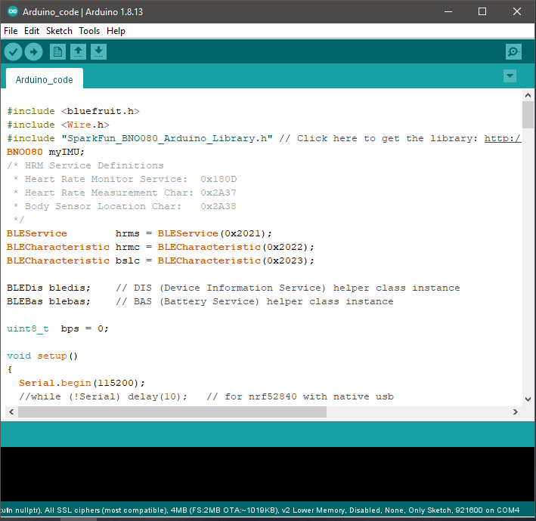

Figure 16 Arduino Sketch in development

# Unity3D

Unity3D is a user-friendly programming environment and a strong cross-platform 3D engine. Unity should appeal to everyone who wants to simply build 3D games and applications for mobile, desktop, the web, and those who are aiming to create interactive simulations and other applications. Outside of video games, the engine has been utilized by the film, automotive, architectural, engineering, and construction sectors, as well as the US Armed Forces.

Since our project was about interactivity, and the end result resembles a Virtual Reality video game in its core: Unity was a perfect candidate to be our smart phone Application development platform.



Figure 17 unity Logo

to represent the movements of the user’s left hand, we need an asset, an asset in unity is a 3D model, the asset we need should be a humanoid containing the human joints, there are many free to use Assets in unity, we chose a humanoid figure for simplicity, this humanoid is presented in the figure below

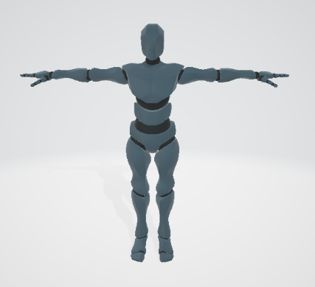

Figure 18 The humanoid replicating the user’s right-hand movement

Development in unity 3D is done in parallel with the last stages of Arduino development, unity provides a simulator inside the software, enabling the testing of developed solution, it’s also capable of integrating external libraries easily, one of those external libraries was the Bluetooth low energy for mobile applications. we used that library to add Bluetooth functionality to our smartphone app.

The development was done in the C# programming language that is similar to C++, it provides full support for object orientated programming as well as inheritance, polymorphism and encapsulation.

Unity 3D was perfect also for its ability to export our project as an android app with the version of our choice, as well as support for exporting as a desktop application, and many options. this can prove to be phenomenal if we ever decide that our project interface is more suitable to be on desktop or any other platform. Also while first aimed to stroke patients, it can be used as a future module for augmented Reality, Virtual reality, Unity Applications.

The figure below shows the unity software is in its last stages of development.

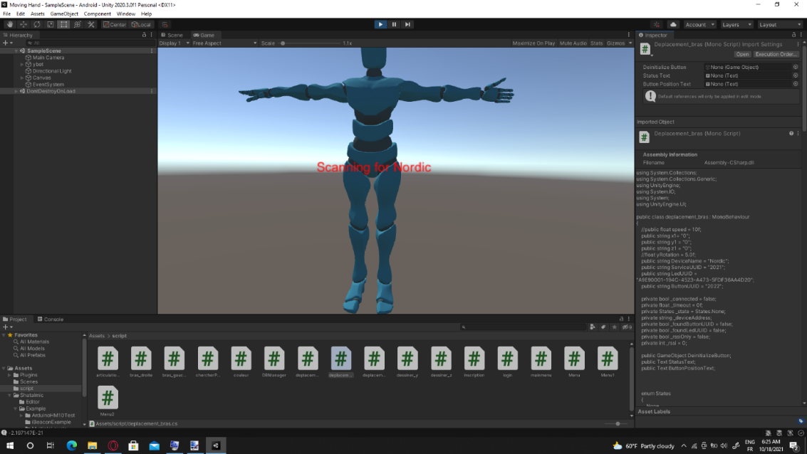

Figure 19 Unity Software in Development

# Hardware Connections:

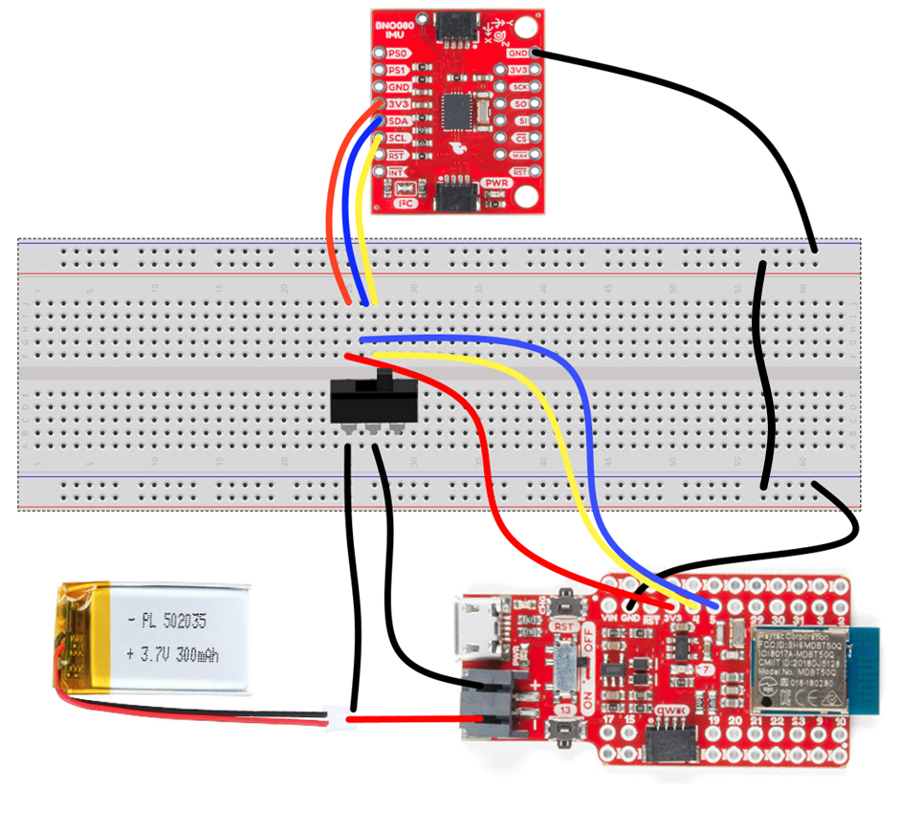The connection of the Sparkfun nrf52840 pro mini with all the system’s components is showing below. A 3.7-volt lithium-ion battery is used as power supply, and a switch was added to restrict or allow the flow of current

Figure 20 The Hardware connections of the prototype

# Conclusion:

Thanks to the prebuilt functionalities in both unity 3d and the BNO080 IMU automatic sensor fusion, we were able to develop a module to aid rehabilitation for stroke patients in a relatively brief time. The next chapter is about studying sensors and the microcontroller in depth for a drowning prevention system with manual sensor fusion.



CHAPTER 3:

In depth study for implementing manual sensor fusion in a drowning prevention prototype



# Introduction

In this chapter, we get ready to implement our own sensor fusion algorithm, for that, an in-depth study was conducted about the microcontroller and the sensors as well as the actuator, we will discuss the reason behind this approach and justify moving to a new development environment.

# Problems with using an automatic sensor fusion:

In this paragraph, we discuss the problems about using the same approach to the second prototype, and why is it better to implement our own algorithm, here are few of them:

High Cost: While an automatic Sensor fusion implemented in an Inertial measurement unit offers great precision and less time to market, it is quite costly, in the previous case, it was 3 times the cost of the microcontroller. This is due to the manufacturer’s development and optimization fees added in the final product cost.

Inability to optimize code: the Sensor is provided with its own library developed fully in C++ code, and ready to use, this code contains way more than the basic functionality we needed, while we can understand and modify the code, its going to be a very difficult and time-consuming procedure

Lack of debugging tools: An automatic sensor fusion algorithm means we have to use prebuilt libraries on the Arduino environment, as sensor libraries often don’t exist in other Integrated development environments or are being sold for further costs. As of today, debugging options are limited to printing debug messages in a serial monitor, this debug method is painfully slow, as the program needs to be executed successfully to the point of the bug. this method is also useless if the bug is a major one that causes the program to not work entirely. The lack of debugging tools also implies that we have to test the code over and over after adding every few lines to ensure no mistakes are being made in the coding. While this may be the fast approach for projects that don’t require a lot of development for the embedded side, in much larger projects that have more functionalities, this can cause huge delays or stop development completely due to inability to pin point the bug location.

Those prementioned reasons were more than enough to push us into creating our own sensor fusion algorithm, the benefits of implementing are many and explained in the next paragraph.

# Benefits of implementing our own sensor fusion algorithm:

In this paragraph, various reasons of how beneficial implementing our own sensor fusion algorithm are discussed in detail,

* Code size reduction: The lack of prebuilt libraries forces us to create our own, this means we have to read the date sheet of each sensor / Actuator and also further familiarize ourselves with a software development kit, consequently, this reduces the size of the code, because we only write the code needed for the functionality we need in our prototype
* Debugging tools availability: The fact that we will write our code from scratch, implies we get to pick our own development environment, we will choose one with the most debugging features available for us, and we will further discuss this new environment in this chapter.
* Cost reduction: by developing our own sensor fusion algorithm, we cut down on the costs drastically, this is achieved because we can only get the core components and code them ourselves manually. reducing the costs by not having them externally coded for us, such as the case of the previous IMU.
* Complete understanding of code on a bare metal level: because we coded the sensor libraries ourselves, we have a good understanding of what’s happening on a deeper level, each instruction of code is clear of ambiguities and easily modified without fear of further implications down the line.
* Ease of further development: since we understand the code on a deeper level, we can easily build layers on it, implementing more algorithms and structures, while being completely aware of any problems that we can encounter and what can be and cannot be done.
* Opportunity to learn on a deeper level: finally, one of the most important reasons, is providing myself of more experience in programming embedded systems, the challenges faced can provide great learning opportunities.

# In-depth Study of Hardware:

The next prototype contains, A pressure sensor, An Inertial Measurement Unit, A GPS module and an SMS module as well as a servo motor and they are all connected to the microcontroller, they are very different components in nature, and implementing a sensor fusion algorithm containing all of them will need an in-depth study of each one, a brief summary of all of them are written in the next paragraphs.

The Microcontroller:

The most important hardware component is the new Arduino nano BLE 33 Board: this board is really convenient due to many features that fit our project perfectly: Arduino's tiniest form factor with Bluetooth Low Energy and embedded inertial sensor.

The main features are:

* the small size that resembles other Arduino nanos
* Bluetooth Capabilities
* Integrated Inertial Measurement Unit: LSM9DS1
* the powerful nrf52840 SoC

The microcontroller pins are shown in the figure below

Figure 21 Arduino Nano BLE 33 Pins

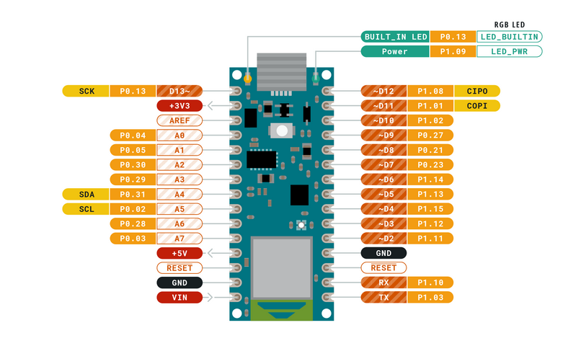

# Inertial Measurement Unit:

# Definition:

Thanks to the recent development of Micro-Electro-Mechanical-Systems production of compact and inexpensive Inertial Measurement Units (IMUs) is possible.

An IMU gives real-time readings of a triaxial gyroscope, a triaxial accelerometer and a tri-axial magnetometer, which may be used to estimate the orientation of a rigid body to which the IMU is mounted. this covers the need for a reliable determination of the orientation of a rigid body relative to an inertial frame.

In the next paragraphs, we briefly define each part of this unit.

# Components:

# Gyroscope:

The gyroscope has some sort of oscillating mass that, when the device changes direction, is exposed to a Coriolis force perpendicular to the oscillation axis and compensated by the elastic force creating the oscillation itself.

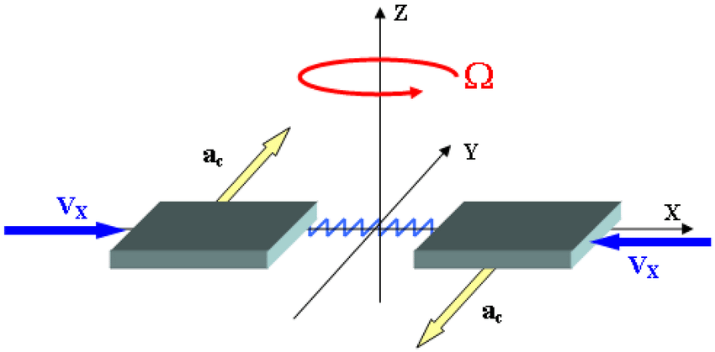It is feasible to indirectly detect the three components of the angular velocity during rotation by sensing such force with a tri-axial capacitive displacement sensor. A sketch shows the principle of operation of a MEMS gyroscope is shown below.

Figure 22 Sketch of the principle of operation of a MEMS gyroscope.

# Accelerometer

An accelerometer is a sensor that detects acceleration, or the rate at which velocity changes in regard to time. When positioned in a gravitational field and not exposed to other non-gravitational excitations, the accelerometer detects the elastic force supporting the weight and so provides both the amount and orientation of the gravitational acceleration. The operating principle is sketched below,

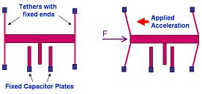

Figure 23 Sketch of the principle of operation of a MEMS accelerometer.

# Magnetometer:

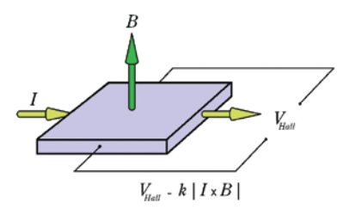The magnetometer is a tool that allows us to obtain a correct heading estimation. the most common magnetometer working principle is the Hall effect method. It works on the principle that a voltage can be detected across a thin metallic element, when the element is placed in a strong magnetic field perpendicular to the element’s plane. The detected voltage is referred to as the Hall voltage.

Figure 24 The Hall Effect principle

Limited-cost IMU systems, provide signals with low resolution and high noise levels, as well as generic time-varying bias terms.

As a result, using appropriate sensor fusion techniques, raw data must be processed to recover smoothed attitude estimations and bias-corrected angular velocity measurements.

In reality, by properly using acceleration measurements, drift induced by numerical integration of gyroscopic readings may be avoided.

However, it is generally recognized that relying just on these two sources of data would not correct the projected heading drift, necessitating the need for the magnetometer sensor data.

# The LSM9DS1 Inertial measurement unit:

The inertial Measurement unit, picked for this project is The LSM9DS1.

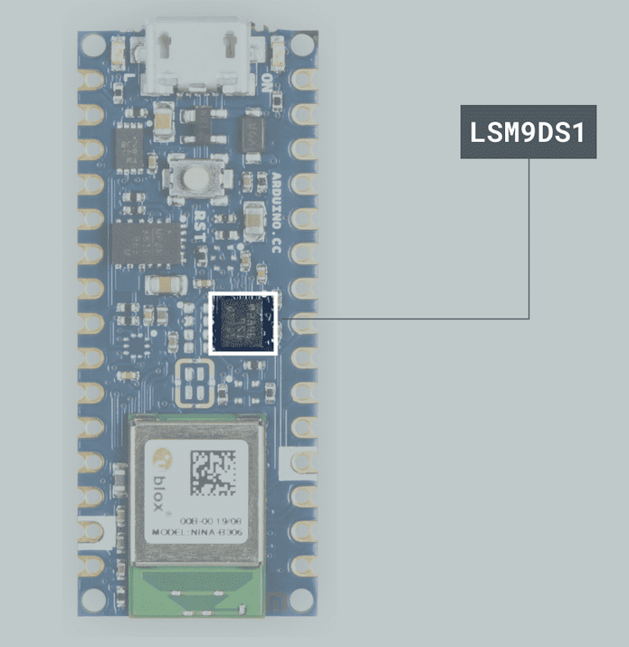The LSM9DS1 is a system-in-package featuring a 3D digital linear acceleration sensor, a 3D digital angular rate sensor, and a 3D digital magnetic sensor. Its location is presented in the figure below.

Figure 25 Location of the IMU in the Arduino Nano BLE 33

The LSM9DS1 includes an I2C serial bus interface supporting standard and fast mode (100 kHz and 400 kHz) and an SPI serial standard interface. Magnetic, accelerometer and gyroscope sensing can be enabled or set in power-down mode separately for smart power management.

While this sensor can offer good measurements and better power saving capabilities than the BNO080, it’s really inferior in precision and unlike the previous Inertial measurement unit, this one only gives raw acceleration, gyroscope and magnetometer measurement.

this sensor doesn’t come factory calibrated; a calibration process needs to be done before the sensor can give correct, drift-free results.

This data output is not enough on its own, a sensor fusion algorithm needs to be implemented and accounted for in the main algorithm.

After research, we found out that There are a variety of Inertial measurement unit sensor fusion algorithms out there, but the two most common in small embedded systems are the Mahony and Madgwick filters.

The sensor fusion algorithm is executed several times per second and we are planning to have the device work for many hours. We picked Mahony’s Algorithm due to being less demanding in processing power making its execution time shorter, consequently making the device more energy efficient. Mahony’s core processes are in the figure below.

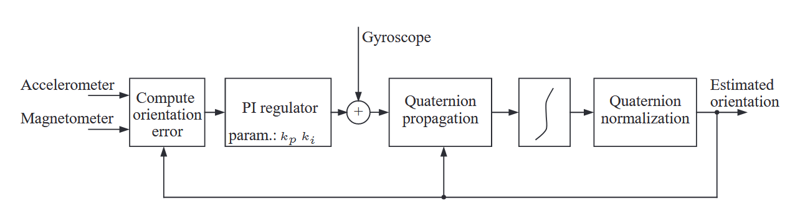

Figure 26 Mahony’s algorithm Block Diagram

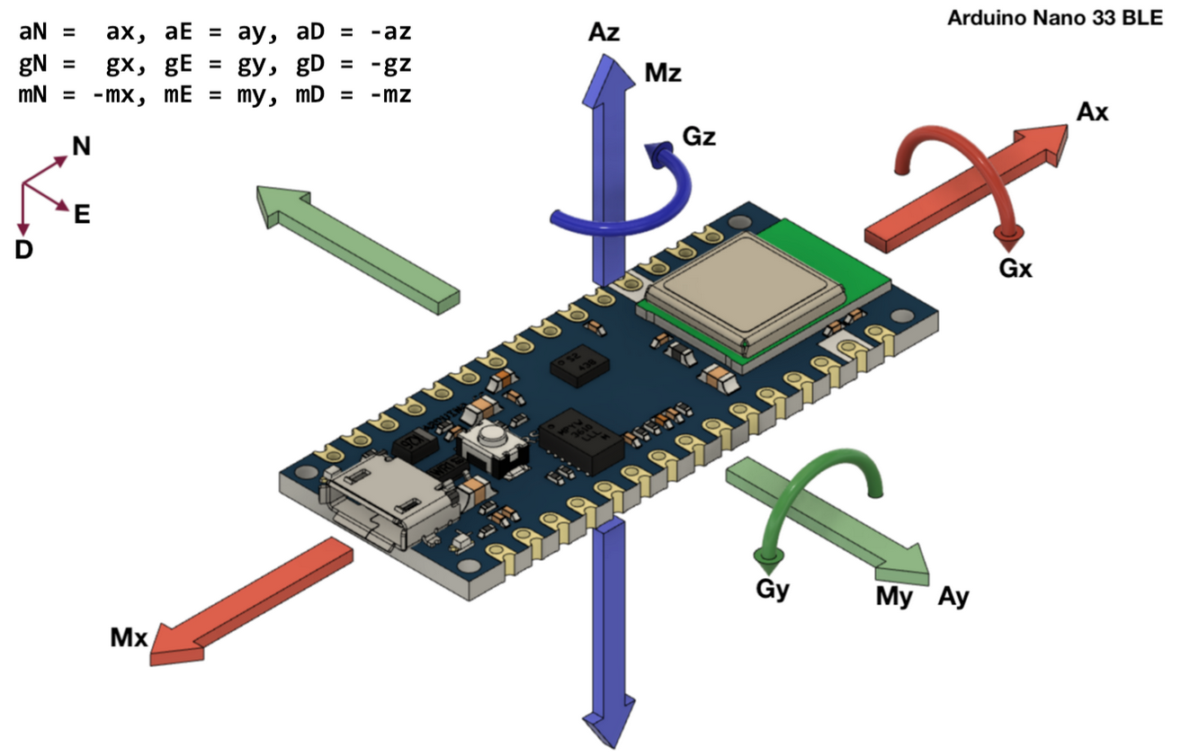the axis of the 3 IMU sensors are sadly not the same, we had to take that into account when implementing this sensor into the sensor fusion algorithm. This is shown in the figure below.

Figure 27 Accelerometer, Gyroscope, Magnetometer Axis of LSM9DS1

# SIM800L Module:

# Introduction:

The SIM800L is a small GSM/GPRS module that is ideal for small projects.

The module supports the GSM/GPRS quad-band network, which is available for long-distance transmission of SMS and GPRS data communications.

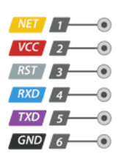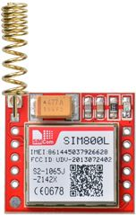The SIM800L communicates with the microcontroller through the UART interface and supports 3GPP TS 27.007, 27.005 and SIMCOM AT improved commands. The figure below presents this sensor pinout.

Figure 28 Sim 800L pinout

# Pinout:

-NET is a pin where you can solder Helical Antenna provided along with the module.

-VCC supplies power for the module. This can be anywhere from 3.4V to 4.4 volts. Remember connecting it to 5V pin will likely destroy your module! It doesn’t even run on 3.3 V! An external power source like Li-Po battery or DC-DC buck converters rated 3.7V 2A would work.

-RxD (Receiver) pin is used for serial communication.

-TxD (Transmitter) pin is used for serial communication.

-GND is the Ground Pin and needs to be connected to GND pin on the Arduino

# Architecture:

This module contains its own power management unit, its own clock and its own digital base band, that means all we have to do is connect it to the digital interface and send the commands needed via the chosen connection protocol, which in this case is UART.

The architecture containing the main component is shown in the figure below.

.

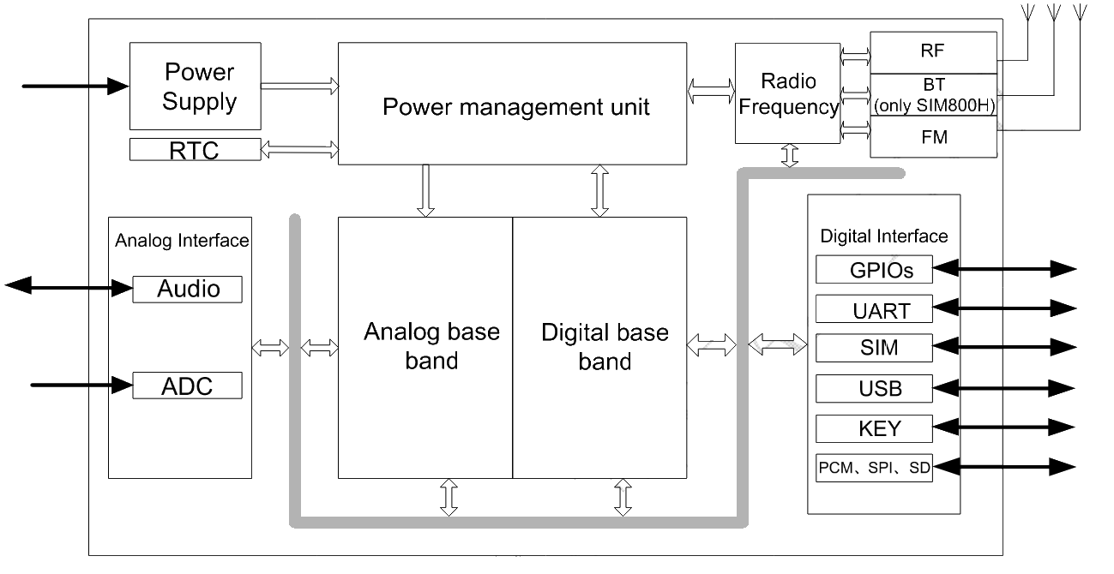

Figure 29 SIM 800L Architecture

# AT commands

To communicate with this module, we send AT commands via the UART interface, The AT instructions are used to control the module's functionality.

They're labeled AT commands because the characters AT must come before each instruction in order to acquire the module’s ATtention.

While the sms800L module got a lot of capabilities, the main functionality is sending ana SMS with the GPRS Data.

The At Commands used are as follows:

AT+CMGF=1: Putting the SMS module to SMS mode.

AT+CMGS=\"+216########\»: Setting the Desired phone Number (presented by ##########) After this command, we transmit via UART our SMS message contents

AT+CMSS=1 Send the SMS, after which we get either “ERROR” Or “OK” identifying the success of failure of the process.

The “OK” Response is sent after each AT command, informing the microcontroller that the command was sent and processed correctly.

# GPS NEO 6M Receiver

# Introduction:

This module is responsible for receiving GPS signals from adequate satellites and processing them, we will use this in our prototype to pinpoint the location of the endangered swimmer.

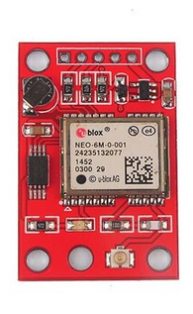This receiver combines a high level of integration capability with flexible connectivity options in a small package. This makes it perfectly suited for mass-market end products with strict size and cost requirements, the receiver and the core components responsible for its functions of this receiver are presented in the figures below

Figure 30 The GPS module NEO 6M

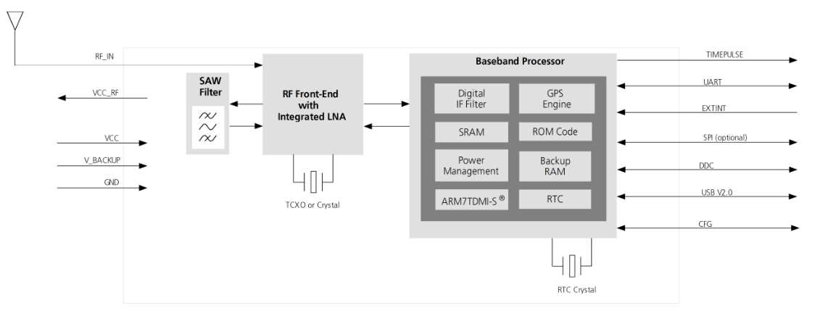

Figure 31GPS neo 6M Function Diagram

# NMEA Sentences:

This GPS module is connected to our prototype via a UART Interface, When the device is powered on, it sends NMEA GPS Sentences

NMEA is an acronym for the National Marine Electronics Association. This is a standard message format for Nearly all GPS receivers.

The NMEA standard is formatted in lines of data called sentences. Each sentence is comma separated to make it easier to parse by computers and microcontrollers.

NEO-6M GPS module updates this information once per second (1Hz frequency) by default. But you can configure it for up to 5 updates per second (5Hz frequency).

The module provides us with those specific sentences once every second:

GPGGA: Global Positioning System Fix Data

GPGLL: Geographic position, latitude / longitude

GPGSA: GPS DOP and active satellites

GPGSV: GPS Satellites in Vue

GPRMC: Recommended minimum specific GPS/Transit data

GPVTG: Track made good and ground speed

While the module provides very useful information, we will only isolate all just one NMEA sentence, this sentence is The GPRMC sentence because contains all the information we need:

The latitude

The longitude

The time (UTC)

And the Mandatory Checksum

# NMEA checksum:

The communication with the GPS module is done only in one way: The module sends data and the Microcontroller processes and parses that data.

In this type of one-way communications, errors can occur undetected, this is why a checksum was included after each NMEA sentence.

The checksum used to detect many data corruption errors and verify overall data integrity;

if the computed checksum for the current data input matches the stored value of a previously computed checksum, there is a very high probability the data has not been accidentally altered or corrupted.

The NMEA protocol implements the simplest form of checksums: The simplest checksum algorithm is the so-called longitudinal parity check, which breaks the data into "words" with a fixed number n of bits, and then computes the exclusive or (XOR) of all those words. The result is appended to the message as an extra word. To check the integrity of a message, the receiver computes the exclusive or of all its words, including the checksum. If the result is different than the calculated checksum, the receiver knows that the transmission had problems.

With this checksum, any transmission error which flips a single bit of the message, or an odd number of bits, will be detected as an incorrect checksum

# MS5387 Pressure sensor

# Introduction:

MS5837-02BA is an ultra-small gel-filled pressure sensor optimized for both altimeter and barometric applications. This waterproof sensor module includes a high-linearity pressure sensor and an ultra-low power 24-bit ΔΣ ADC with internal factory-calibrated coefficients.

It provides a precise digital 24-bit pressure and temperature value with different operation modes   
that allow the user to optimize for conversion speed and current consumption. A high-resolution   
temperature output allows the implementation of an altimeter/thermometer function without any   
additional sensor. The MS5837-02BA sensor can be interfaced to any microcontroller with   
I2C-bus interface. The tiny pressure sensor is presented in the figure below

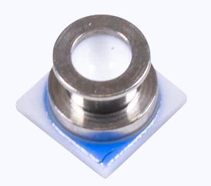

Figure 32 MS5837 Pressure sensor

# Features

The sensor contains many features such as:

* Providing precise digital 24-bit pressure and temperature value with ultra-low power consumption
* Supporting design flexibility with ultra-small size while providing precise outputs: 3.3 mm x 3.3 mm x 2.75 mm
* Enabling depths up to 100 m with watertight seal with 1.8 mm x 1.8 mm O-ring
* Enhanced construction and design materials offer a high endurance, chlorine resistant model suited for devices that will be exposed to environments with chlorine
* Reducing signal noise and interference that may be experienced with sensors installed in plastic housings or high electrical noise environments with these shielded models

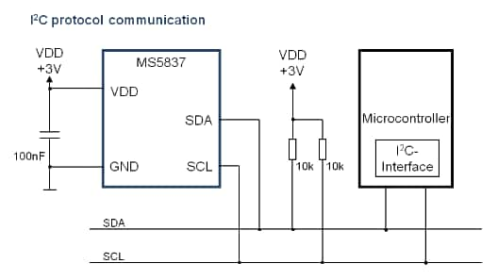This sensor is communicating with the microcontroller via the I2C connection Protocol, the connections are shown in the figure below

Figure 33 Communication between the pressure sensor and the Microcontroller

# Calculating Pressure:

To calculate the pressure the Microcontroller first reads the Values stored in ROM, those represent the calibration values. Then it sends the order to convert the analog readings into digital ones, and follows the instructions detailed in the figure below.

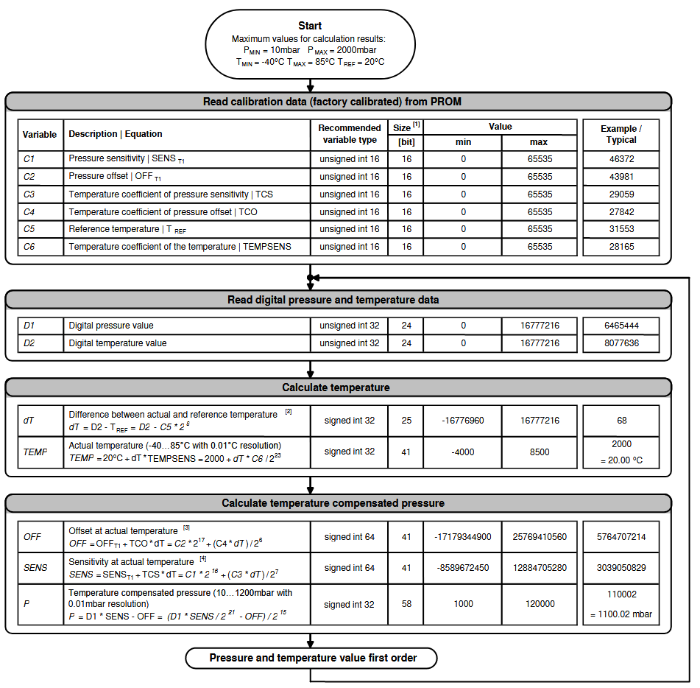

Figure 34 Calculating pressure using the MS5837-02BA

# Servo Motor:

# Introduction:

Finally, to ensure the airbag mechanism functionality, need a Servo Motor,

We picked a unique motor which is the Hitec HS-646WP servo. What separates this servo from the rest is that it is waterproof. It also easily provides enough force to start the airbag mechanism.

The servo motor has 3 pins, Signal, VCC, and GND and is presented in the figure below

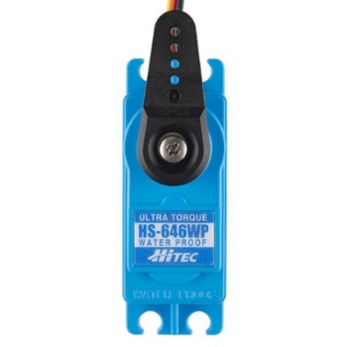

Figure 35 The Servo Motor

# PWM motor control:

The movements of the Servo are controlled by a Pulse width modulated signal,

Digital control is used to create a square wave, a signal switched between on and off.

The period of this signal is 20 MS, TON is the time where the signal is ON in that period of time.

the duration of "on time" is called the pulse width.By changing the TON time, we are able to control the servo motor. In standard servo motors, this time varies between 1 and 2 Ms.

 the figure below shows 3 examples of those signals and their response.

Figure 36 Servo Motor Response

# New IDE: Segger Embedded studio

While Arduino IDE is perfect for quick prototyping and giving a proof of concept, it doesn’t offer debugging features, it takes a long time to troubleshoot problems, and in Arduino, we work with premade libraries, those libraries are often not optimized and sometimes don’t implement all the features needed, not to mention most of the code isn’t required

At the same time, Nordic Semiconductor, the makers of the NRF52840 chips, provide a Free for commercial use Integrated Development Environment, that comes with its own Development Kit.

This Enables us to do Bare-Metal Programming: This means there is no operating system supporting it, we interact with the system at a hardware level, this enables us to further optimize our code and any line of code can be modified to our liking, even the basic communication protocols such as UART and I2C.

Segger Embedded Studio is the All-In-One solution for managing, building, testing and deploying embedded applications. This means smooth, efficient development operations thanks to its wide range of features. The powerful project manager enables the management of projects large and small. Version control features enable automatic application deployment.

With a Visual Studio-like appearance, SEGGER’s Embedded Studio enhances both efficiency and user friendliness. Embedded engineers now enjoy the ease of use that many software developers know thanks to its intuitive yet customizable layout. Shown in the figure below.

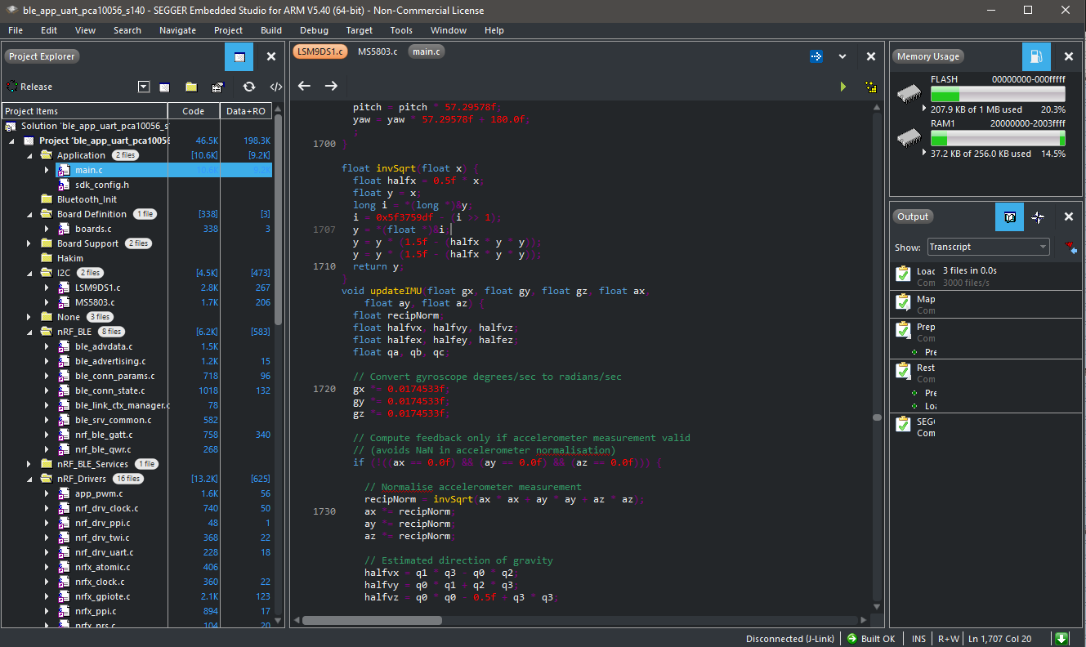

Figure 37 Segger Embedded Studio Environment

# Debugging Technology: J-link

In addition to their Integrated Development environment, SEGGER J-Links are the most widely used line of debug probes on the market. They have provided solid value to embedded development for over a decade. Unparalleled performance, an extensive feature set, many supported CPUs & compatibilities with popular environments all make J-Link an unbeatable choice.

To use this technology, we needed a j-link intermediate hardware, luckily this hardware is present in All recent Nordic Development kits. We used an NRF52840 development kit as J-link debugger, for the Arduino nano Ble 33, the Pins needed for the connection are as follows, present in the figure,

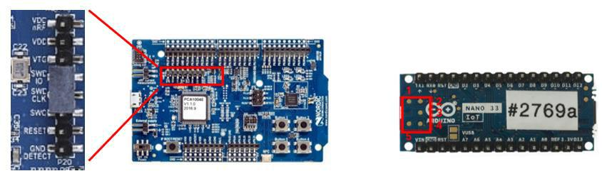

Figure 38 Debugging pins on Arduino BLE 33 and Nordic DK J-link

after soldering jump wires to the Arduino nano Ble 33 the final connections for debugging are made, and the Microcontroller’s code was ready to be debugged and developed , the connections are shown in the figure below

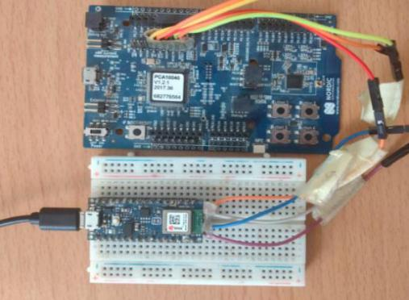

Figure 39 Debugging on Arduino BLE 33

# J-Link RTT – Real Time Transfer

SEGGER's Real Time Transfer (RTT) is the proven technology for system monitoring and interactive user I/O in embedded applications. It combines the advantages of SWO and semi hosting at very high performance. It has many features such as:

-Bi-directional communication with the target application

-Very high transfer speed without affecting real time behavior

Uses debug channel for communication

No additional hardware or pin on target required

Supported by any J-Link model

Supported by ARM Cortex-M0/M0+/M1/M3/M4/M7/M23/M33 and Renesas RX100/200/600

Complete implementation code providing functionality and freedom

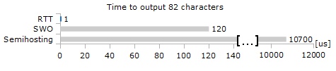The performance of SEGGER RTT is significantly higher than any other technology used to output data to a host PC. An average line of text can be output in one microsecond or less. Basically only the time to do a single memcopy() instruction . A comparison between other technologies and RTT is shown in the figure

Figure 40 Comparison between each debugging technology

RTT technology removes the worry that Debug messages are taking time and memory, it meant we can expect the exact same functionality whether we are debugging or testing our software in a real-world scenario.

# Conclusion:

Thanks to this in-depth study, we know exactly how to use the chosen hardware, and consequently start developing our own solution with our own sensor fusion algorithm, but before that, a study of the problem needs to be conducted, as well as the analysis and conception stage. this will be addressed in the next chapter



CHAPTER 4

Drowning prevention prototype with Manual sensor fusion

# Introduction:

In this chapter we will first introduce general statistics and information about drowning, then we move on to the analysis and conception of a solution. And finally, we will finish by the implementation and the final results.

# Drowning:

# Definition

Drowning is the process of experiencing respiratory impairment fro

m submersion or immersion in liquid. Not all drownings are fatal. There are mainly to types of drowning:

-Fatal drowning happens when the drowning results in death.

-Nonfatal drowning happens when a person survives a drowning incident with a range of outcomes, from no injuries to very serious injuries or permanent disability

# Magnitude of the problem:

Far too many people around the world know the pain of losing a loved one to drowning. Each year almost 360 000 people die from drowning – over 90% of them in low- and middle- income countries. More than half of these deaths are among those younger than 25, with children aged under 5 facing the greatest risk. Drowning, one of the world’s most preventable, neglected and pressing public health issues, is the third leading cause of death worldwide for those aged from 5 to 14. Despite these tragic facts, drowning prevention gets relatively little attention and few resources.

# Active Solutions:

some solutions are proposed to address this leading cause of lost lives, yet their effectiveness is being questioned, as shown in the figure below. Their types are defined in the next paragraphs.

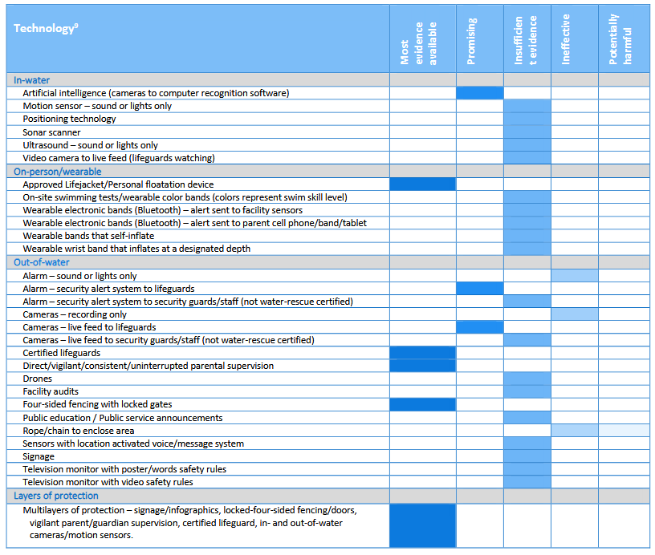

Table 6: Active solutions

# In-water and wearable on-person technology:

tracks the movements and/or depth of in-water participants using recognition software and sounds an alarm in the event of a drowning incident. The   
purpose of the sound and/or strobe light alarm is to hasten and improve the rescue and reaction-time of lifeguards on duty and/or parent/guardian/supervisors.

# Out-of-water technology

relays a message, alarm or image to a central location in an effort to impair and/or track movement and/or locate an individual(s) to prevent water entry and/or improve the rescue and reaction-time of rescuers during a water-related incident.

# Combined in-water and out-of-water technology

sends images to recognition software which differentiate between normal and abnormal water movement and sounds an alarm to a lifeguard team/aquatic staff/supervisor/parent/guardian. The purpose of the combined system is to identify someone in distress that on duty lifeguards/staff/supervisor/parent/guardian have missed.

# Layers of protection

usage of in-water and out-of-water technology combined with in-person supervision (e.g., vigilant parents/guardians and a lifeguard team).

# Future Preventative measures

New drowning prevention technologies are being created with more on the horizon. Evidence-based research on the effectiveness of these systems and devices is needed, And Collaboration with drowning prevention technology companies is being sought.

# Types of drowning:

# Active Drowning:

When a person is actively drowning, they are aware that they are in peril. In this scenario, the victim finds himself in a difficult predicament. Depending on swimming ability, the response may change from person to person. In reality, there are two sorts of active drowning victims:

# Non-swimmer victims:

are individuals who cannot float in water on their own in a normal scenario, and hence lack the capacity to swim.

Such victims find themselves in deep water all of a sudden.

As a result, they would quickly fear and begin a seizure known as Instinctive Drowning Response IDR.

This sort of victim is unable to summon aid since their main concern is breathing once their mouth reaches the water's surface.

# Swimmer victims

These are people who can swim under regular circumstances.

They can, however, be victims of a drowning occurrence if they are weary in deep water, get a cramp and are unable to swim, or simply suffer some other form of disaster without losing consciousness.

These victims, in general, remain afloat as soon as the accident happens and are able to request assistance.

# Passive Drowning:

Passive drowning happens when a swimmer is asleep in the water, such as while suffering from a sudden illness like a heart attack.

This sort of victim drowns after losing consciousness and showing no obvious reaction.

Furthermore, new drowning study has revealed that small children (under 5 years of age) do not struggle for survival while submerged in water.

As a result, this group of victims should also be classified as passive drowning victims.

Unlike active drowning, passive drowning occurs quietly. As a result, the victim might vanish underwater in seconds.

# Instinctive Drowning Response

Frank Pia utilized rescue data from swimmers who drowned in Orchard Beach, New York, collected over a 21-year period

He demonstrated the Drowning Instinctive Response, which symbolizes the person's attempts to prevent suffocation or drowning.

Choking in water causes a nervous system constellation that causes outward motions that are easily detected by skilled rescue crews

During the IDR, Pia noticed that these individuals fit a specific profile:

- Drowning victims are unable to control their arm motions freely.

- the sufferers are alternating between vertical up and down movements

-Victims may struggle on the water's surface for 20 to 60 seconds before being submerged, whilst youngsters have a shorter period.

- Drowning victims cannot voluntarily control their arm movements.

- Victims are physiologically incapable of seeking assistance.

Figure 41 Instinctive Drowning Response

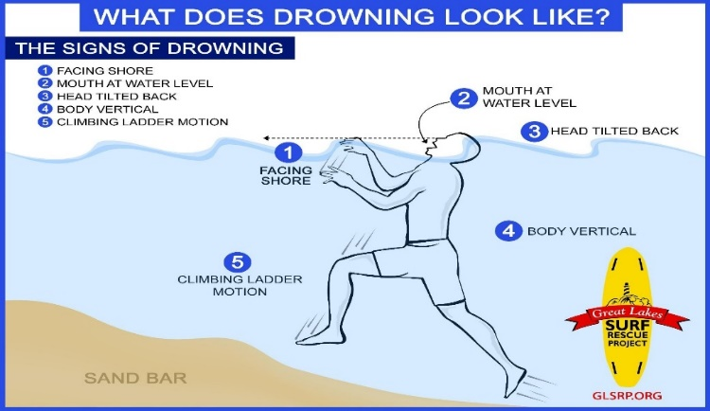

# Interpretation:

The effectiveness of Drowning prevention technologies is still lacking evidence, and those technologies are still unavailable in most countries’ under-development, in which drowning is most fetal due to Lack of immediate response to a drowning incident or even the absence of it.

Our goal through this research was clear: the development of a cost-effective wearable solution, capable to automatically save both active and passive drowning victims. and when possible, to Take advantage of the GPS worldwide availability and the GPRS Network to further contribute to the success of the operation.

# Analysis and Conception:

# Functional needs:

- the device needs to rescue swimmers in risk of drowning by inflating an airbag existing inside swimmer shorts

- the device should send and SMS in case of drowning with the GPS coordinate of the Rescued swimmer.

- the device should always calculate the user’s Pressure and Position

# Non-functional needs:

Water Proof: This device functions mainly in the water, it should handle the varying water pressures and function normally under those conditions.

Energy-Efficient: the device should handle few hours sessions in water while preserving as much energy as possible, the rescue mechanism has many power-hungry functions like Sending SMS, Getting GPS location, and especially controlling the airbag mechanism. Keeping energy for those functions is of the utmost importance.

Compact: The prototype is going to be installed in the user’s swim wear, its important the user has a comfortable experience and that our prototype be as less of an inconvenience as possible for the swimmer.

Reliability: The Rescue mechanism should not be working when its not intended to.

Performance: The proposed solution must be optimal in terms of processing time, therefore, the execution time must be as close as possible to real time

# Global architecture:

This prototype is basically composed of 6 modules, an SMS ( GPRS ) Module, Capable of sending SMS messages , a GPS module, whose role is to locate the prototype and give GPS location information, An inertial measurement unit module detecting the motion of the user in the water, and finally the most important part, the processing and communication module, handling the information from the sensors, Communicating using Bluetooth with the mobile app , and finally executing the rescue process with the help of the inflation module. The figure below represents the Global architecture.

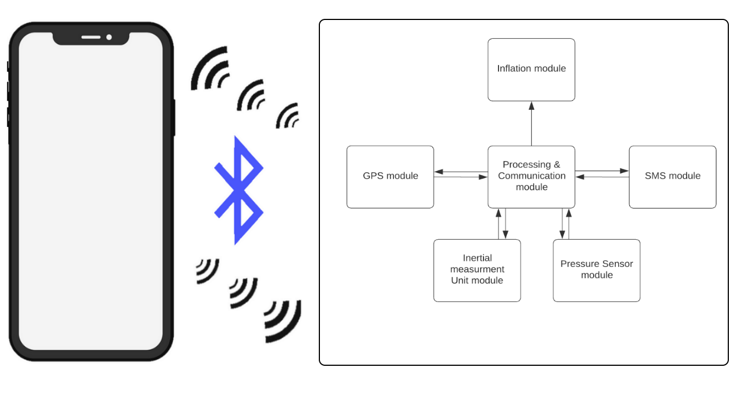

Figure 42 Global Architecture

# detailed Architecture:

in this section we will talk in detail about the architecture, starting from the user’s input and ending with the rescue routine. the figure below shows the main processes our prototype is going to execute, in order, to ensure the desired functional needs. The architecture in detail is presented in the figure

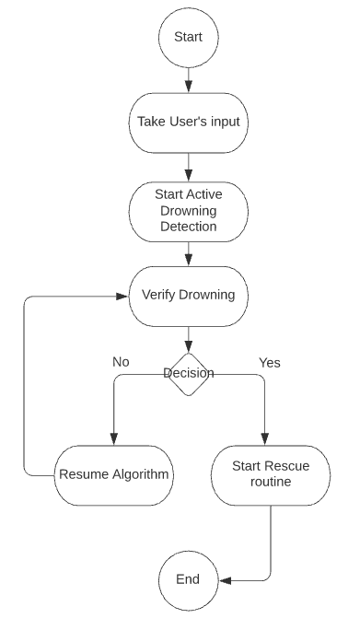

Figure 43 Detailed processes architecture.

# User’s Input:

Taking the user’s input is the first state of our prototype, its processes are shown in the figure and further explained in the table below

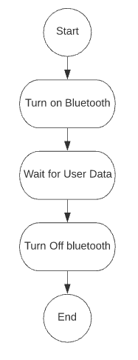

Figure 44 Taking User’s Input

|  |  |
| --- | --- |
| Process | Description |
| Turn on Bluetooth | The device starts advertising, and waiting for the smart phone application connection |
| Wait for user Data | This process starts by the user entering a custom password on the smart phone application. and then proceeds to enter the required information this is basically the Maximum user time underwater as well as the user’s nose to prototype distance. (This is basically half the user’s height.) the prototype waits for the user to send the required information, and then sends the information back to the user, to verify the information. if a mistake happens, the user can always restart the prototype and repeat the process. |
| Turn Off Bluetooth | The device disconnects from the mobile app, and turns off the Bluetooth functionality, ensuring maximum power saving. |

Table 7: User’s Input Description

# Active Drowning detection

Active drowning detection is the second state of our drowning prevention system, it’s one of the most repeated states in our prototype, the next table describes its process and the figure presents them.

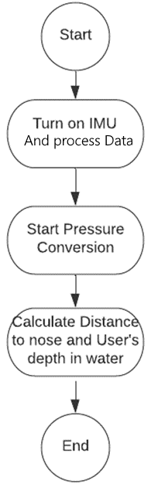

Figure 45 Starting active drowning Detection process

|  |  |
| --- | --- |
| Process | Description |
| Turn on the IMU & process its data | One of our main sensors, this sensor comes turned off initially and should be turned on and then have its data processes by the sensor fusion algorithm, the end result is the 3 Euler angles, that determine the user’s orientation in 3D space |
| Start Pressure conversion | To detect the device’s underwater distance, we calculate the pressure, then we used a simple formula to convert that pressure into underwater depth. |
| distance to nose and user’s depth in water calculations | Thanks to those two variables, we now have what we need to calculate the user’s distance to nose, and the user’s depth in water. |

Table 8: active drowning Detection process description

# Drowning Verification:

Drowning verification state is executed after sensor data is delivered, the explanation of this process is done in the table, and the figure below shows its core components

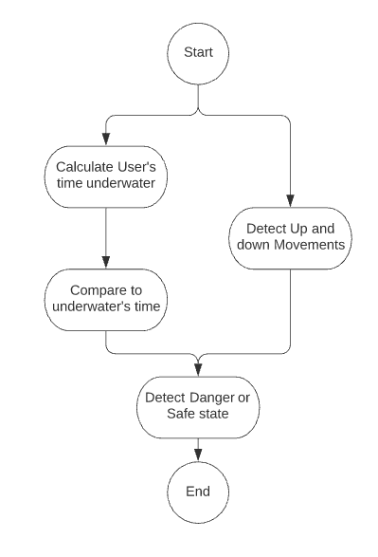

Figure 46 Drowning Verification Process

|  |  |
| --- | --- |
| Process | Description |
| Calculate the user’s Time underwater | By using the one of the timers’ functionalities provided by our microcontroller and the depth of the user resulting from the pressure conversion, we can easily calculate the user’s time underwater. this is used to save mainly passive drowning victims. |
| Compare to underwater time | The user’s time underwater is then compared to the information provided by the user at the initial stage. |
| Detect up and down movements | To save active drowning victims, The algorithm runs also takes into account the user’s depth changes, if the user is struggling, going up and down in a quick manner. |
| Detect danger or Safe state | The danger state can be detected if the user’s time underwater exceeds the time provided, or the user’s struggle to breathe by moving up and down quickly. Otherwise, the system stays in the “safe state”. |

Table 9 : Drowning verification process description

# Use case diagram:

In this section, we further Explain our prototype functions using a use case diagram we first define the actors and the processes, and then represent them in the figure below

Actors:

Primary Actor:

The Swimmer: The user who’s going to wear the drowning prevention system.

Secondary Actors:

Water pressure: The water pressure is applied to the pressure sensor, to give the depth of ther user

Motion: The user’s Motion is being detected by the IMU, and used to position the user in 3D space.

Smartphone: The smart phone is responsible for data exchange with our system during the initial configuration.

Detailed description:

System On and off: The user can turn on the drowning prevision system or turn it off.

Calculate the depth in water: The pressure sensor provides reading that are later used to know the user’s depth in the water.

IMU sensor fusion and position calculation: the system must detect the different movements and positions of the swimmer

• Drowning detection: Drowning detection is the most important feature. In order for the system to detect a drowning accident, it uses the parameters already configured in the smartphone, the swimmer's depth in the water, his movements and his positions which are calculated by the various sensors.

• System connection: To exchange data, our system is linked to a smartphone using BLE (Bluetooth Low Energy).

System configuration: this allows you to configure the data of the user wearing the drowning prevention swimming shorts.

Getting GPS data: in this process the GPS module is receiving satellite signal and triangulating the user’s location

Open airbag: The main safety mechanism in the drowning prevention system, the deployed airbag should save the swimmer from a dangerous situation.

Send GPS data and time via SMS: To further improve the rescue operation and ensuring the survival of the swimmer, GPS location and time of incident is communicated via SMS.

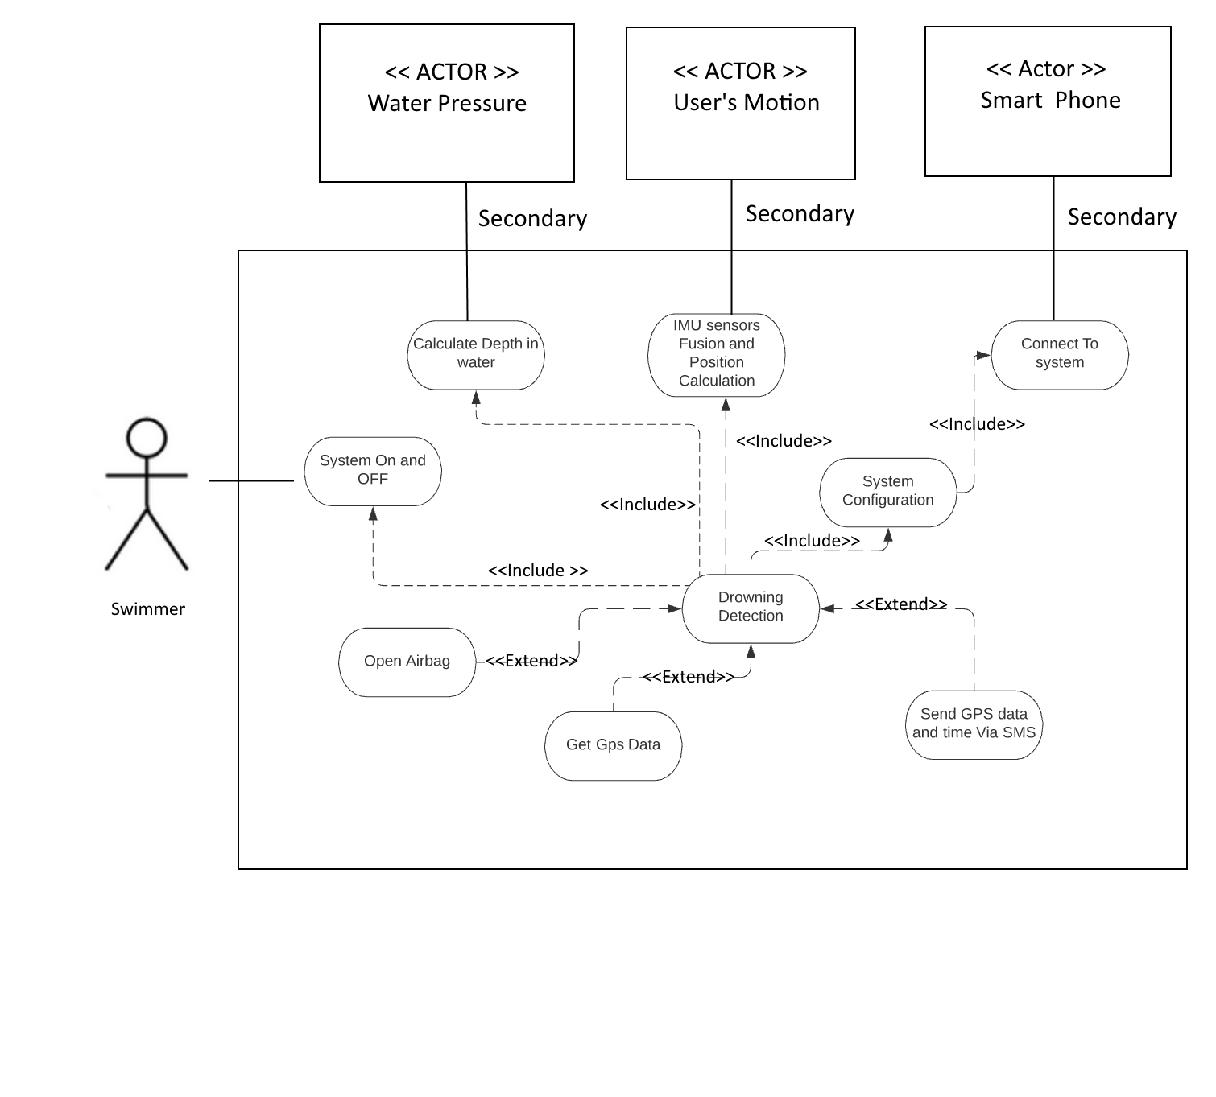

Figure 47 Drowning prevention prototype use case diagram

# Sequence diagram:

To ensure more clarity about the chronological order of the processes, we added a sequence Diagram presented below, and discussed in detail the chronological sequence of the prototype execution

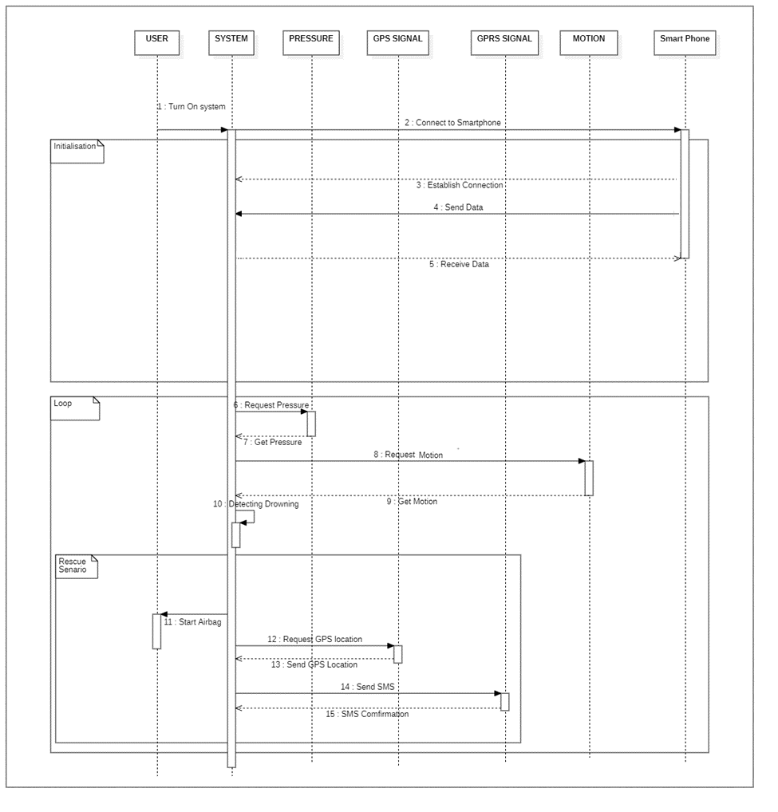

Figure 48 Sequence Diagram

1: Turn on system: The drowning prevention system is turned on

2: Connect to smartphone: The device then connects to the smart phone and waits for the connection to be established

3: Establish connection: the Bluetooth connection is now established; the prototype is ready to send and receive data.

4: Send Data: the smart phone sends the configuration information to the device

5: Receive data: the Smartphone application then receives back configuration data, for confirmation.

The device then enters a loop:

6: Request pressure: the prototype gives the command to the pressure sensor to start converting pressure to a digital signal.

7: Get pressure: The device is getting pressure readings from the pressure sensor to determine the user’s depth in the water.

8: Request Motion: the prototype requests the last read accelerometer, gyroscope and magnetometer values.

9: Get motion: Motion data is received and being processed to determine the user’s orientation and position in space.

Steps 7 to 9 keep repeating until a drowning scenario is being detected

10: Detecting drowning: the algorithm threshold values are exceeded: A drowning scenario is being detected.

Next, the drowning prevention scenario is taking place.

11: Starting the airbag: the airbag existing in the user’s shorts are being inflated.

12: Request GPS location: After inflation, the GPS starts working and looks for a satellite to finally triangulate the user’s location.

13: Send GPS data: After successful triangulation, the GPS module is sending back the received data.

14: Send SMS: the GPS module provided the information we need. The time and the location of the user’s is sent to the module and an SMS should be sent.

15: SMS confirmation: The prototype waits for the SMS sending to be confirmed.

# Software environment:

We mainly used Segger embedded studio to develop the prototype, but other additional software was used, we mention them in the next paragraphs

# Android studio

In addition to providing the free access to an integrated development environment, Nordic Semiconductor provides a Container app for Nordic Semiconductor Bluetooth Low Energy demo apps called “NRF toolbox”.

NRF toolbox provides many features and a template to work with, we used the code provided by Nordic in android Studio. To develop our mobile application, the development goals were simple, an application able to connect with Bluetooth low energy securely, and then communicate the maximum time underwater as well as the height from the belly to the nose, the interface of the app is shown in the right in the figure, and the development is shown to the left.

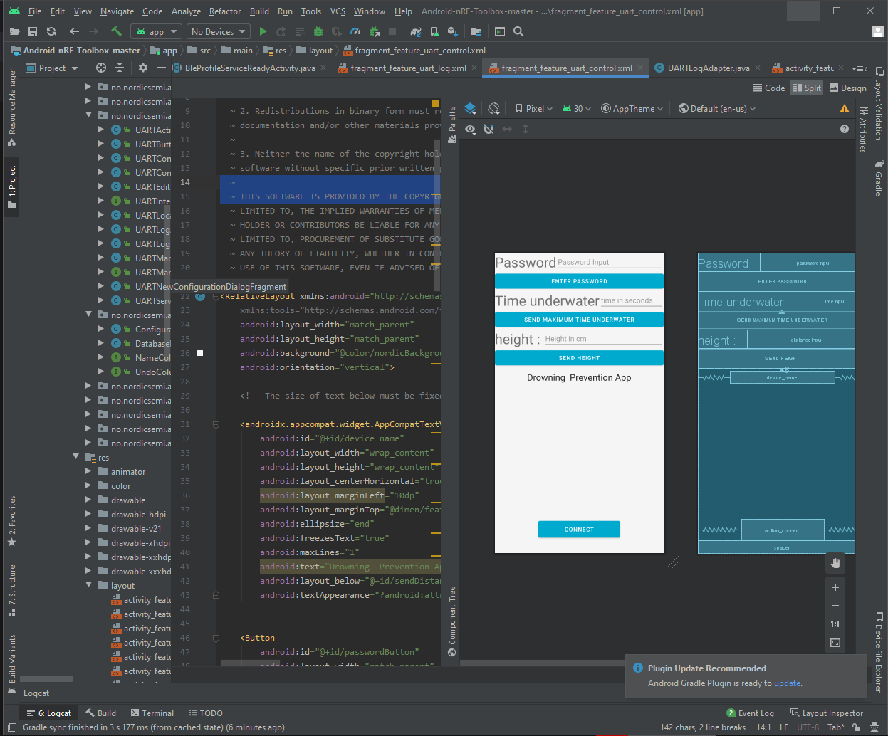

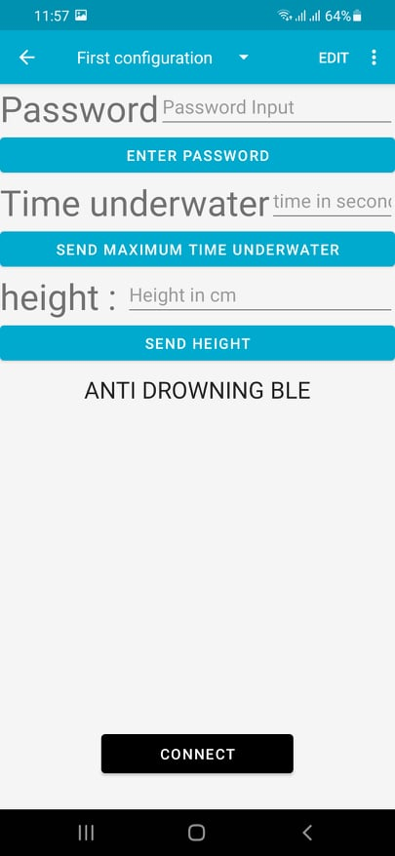

Figure 49 APP Interface

Figure 50 Drowning prevention application on Android Studio

Figure 50: App’s interface

# Processing:

Since we developed a manual sensor fusion algorithm, the sensors embedded in the IMU, which are the Accelerometer, magnetometer and gyroscope all need to be calibrated, After the calibration process, A verification needs to be taken place, this is why we used Processing.

Processing is a flexible software sketchbook and a language for learning how to code within the context of the visual arts. Since 2001, Processing has promoted software literacy within the visual arts and visual literacy within technology. There are tens of thousands of students, artists, designers, researchers, and hobbyists who use Processing for learning and prototyping.

Thanks to its ability to render 3D graphics in real time with microcontroller data as an input, we can easily see if our calibration is driftless and correct or otherwise. A 3D model was picked to emulate the rotation and shown in the figure below,

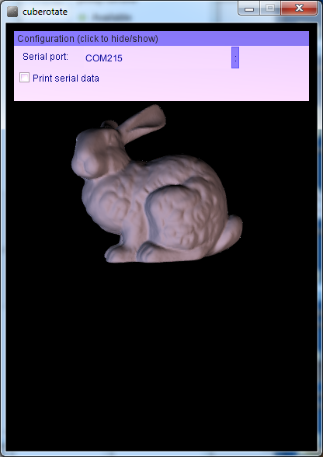

Figure 51 Processing sketch output showcasing a rotating 3D object

# Eagle

To start the Testing, we had to build a PCB, featuring all the connectors needed and the voltage regulation components, we used EAGLE for PCB Designing.

EAGLE is electronic design automation (EDA) software that lets printed circuit board (PCB) designers seamlessly connect schematic diagrams, component placement, PCB routing, and comprehensive library content.

The figure below shows the final stages of this process.

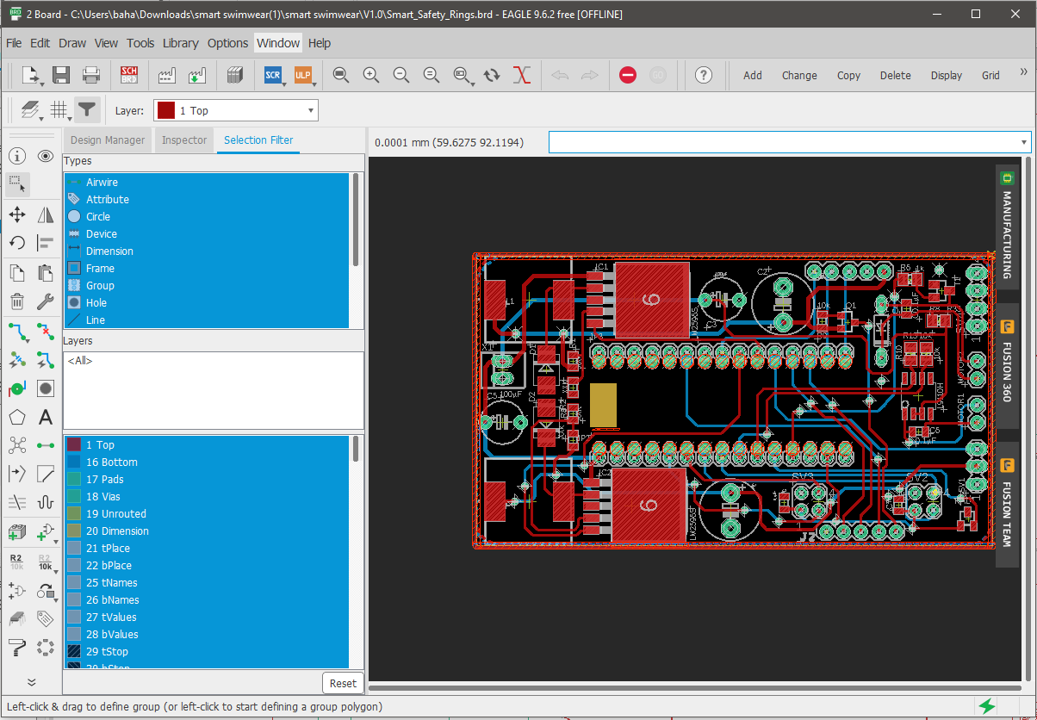

Figure 52 PCB designing in Eagle

# Hardware Connections:

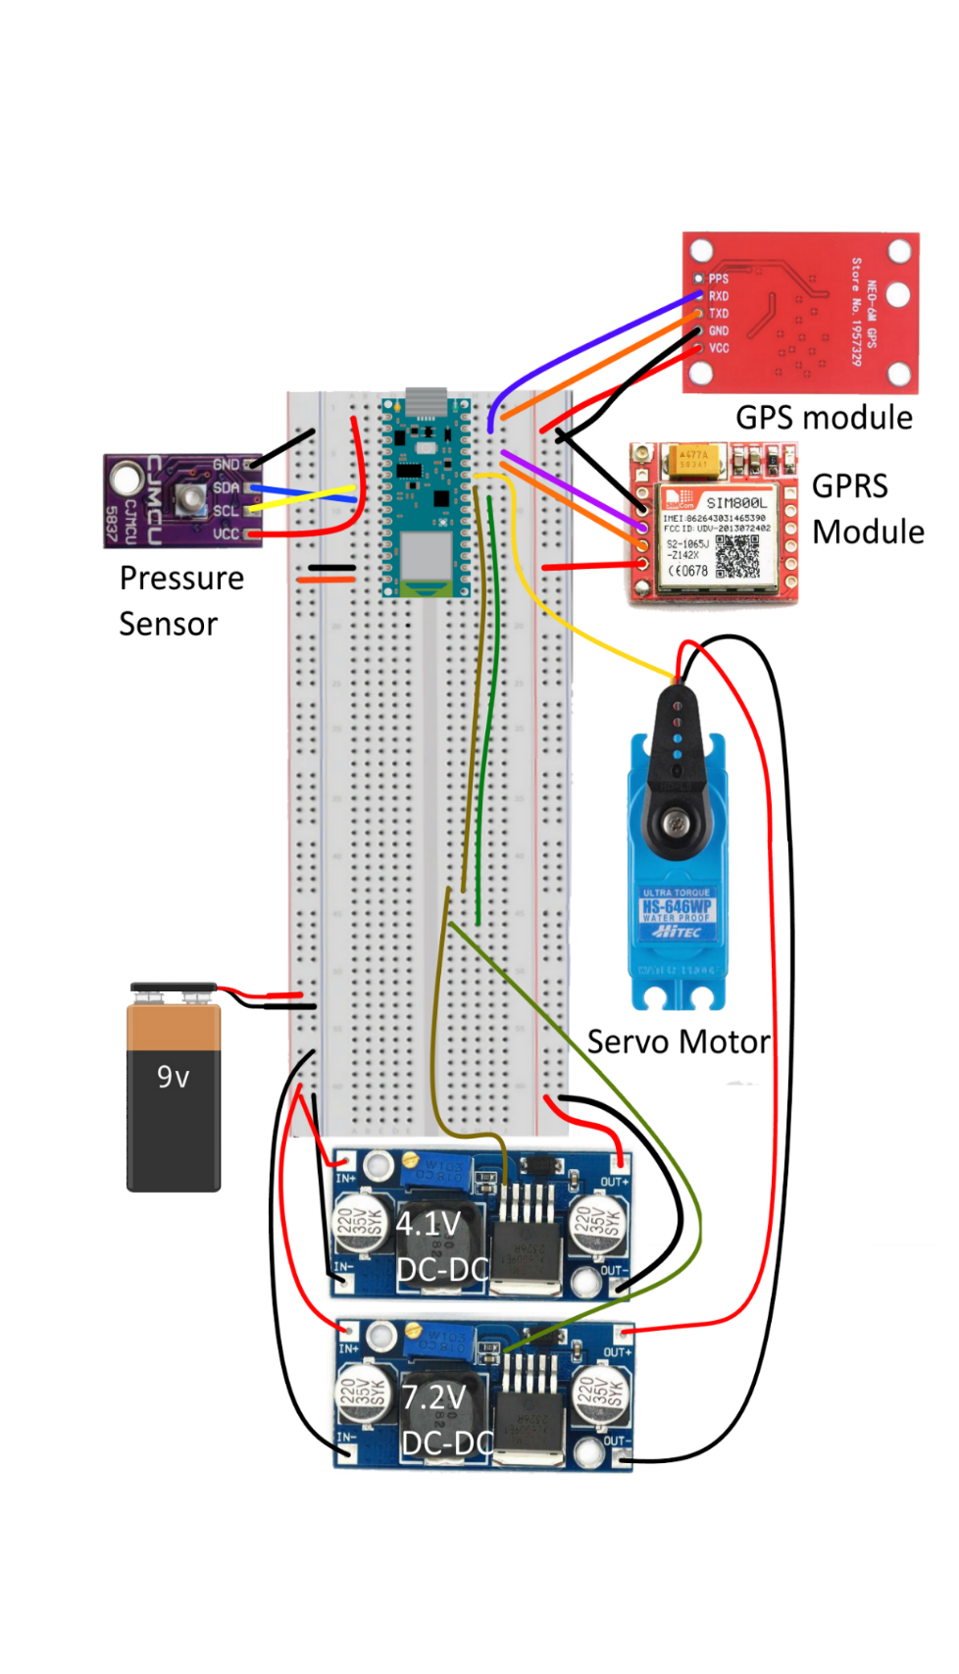we had to build a functioning prototype for development, we connected our sensors as shown in the figure, to ensure the prototype varying voltage needs, we used two DC-DC steps down converters as demonstrated in the figure

Figure 53 Hardware Connections

# Voltage Regulation

As mentioned above, the components had varying voltages needs, to ensure clarification, the table was drawn

|  |  |  |
| --- | --- | --- |
| Component | Operating Voltage | Voltage Delivered |
| Arduino Nano Ble 33 | 4V – 21 V | 9 V |
| HS -646 WP servo Pressure | 6V – 7.4V | 7.2V (9V stepped down to 7.2V) |
| MS 5837 Sensor | 3.3V | 3.3V (using Arduino’s nano Ble 33 internal voltage regulator) |
| NEO 6M GPS module | 3V-5V | 4.2 V (9V stepped down to 4.2V) |
| SIM 800L GPRS module | 3.7V to 4.5V | 4.2V (9V stepped down to 4.2V) |

Table 10: Voltage regulations

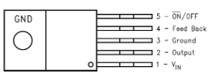Those voltage Regulations are based on the lm2596 switcher presented in the figure below , the ON/OFF Pin Allows the switching regulator circuit to be shut down using logic signals thus dropping the total input supply current to approximately 80 μA. By shutting down the regulators, we consequently shut down the sensors, achieving maximum power optimization possible.

Figure 54 the lm2596-ADJ switching regulator

## General Conclusion

The developed prototypes are part of the end of study project for the degree of engineering in electronics and communication from Enet’com Sfax, they were the fruit of the work inside “Compi-Technology” Start-up.

This entailed creating two separate prototypes based on different Inertial measurement units; one implementing automatic prebuilt sensor fusion for stroke patients, detecting slight movements of a limb and replicating them on mobile platform.

and another implementing a manual sensor fusion algorithm for a drowning prevention wearable prototype, capable of detecting a dangerous scenario, and improving the chances of survival in case of an emergency, thanks to its built-in rescue mechanism and communication modules.

This project taught me that challenges need patience, sacrifice, and a deep passion to be overcome, and made me realize how infinitely valuable is the knowledge acquired throughout my academic years.

And at last, we anticipate that such an effort will live up to the confidence that has been put in us and satisfy the members of the jury.

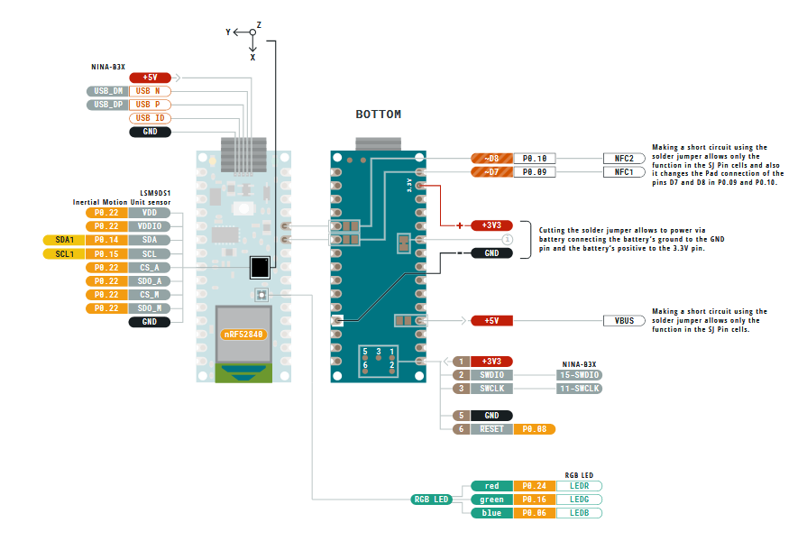ANNEX 1: 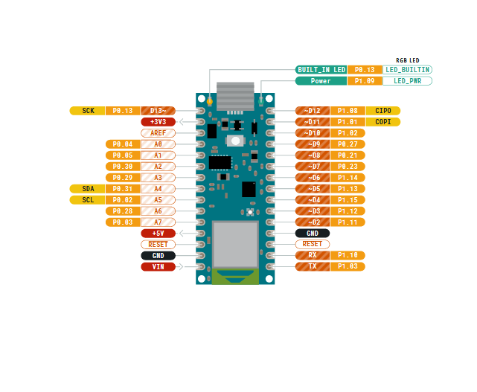Arduino NANO BLE 33 Board Pinout

ANNEX 2: I²C communication

I²C Data

Data must be sent and received to or from the slave devices, but the way that this is accomplished is by reading or writing to or from registers in the slave device.

Registers are locations in the slave's memory which contain information, whether it be the configuration information, or some sampled data to send back to the master. The master must write information into these registers in order to instruct the slave device to perform a task.

While it is common to have registers in I2C slaves, please note that not all slave devices will have registers. Some devices are simple and contain only 1 register, which may be written directly to by sending the register data immediately after the slave address, instead of addressing a register. An example of a single-register device would be an 8-bit I2C switch, which is controlled via I2C commands. Since it has 1 bit to enable or disable a channel, there is only 1 register needed, and the master merely writes the register data after the slave address, skipping the register number.

Writing To Slave in the I²C Bus

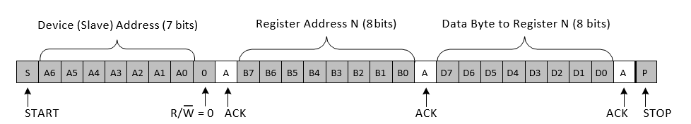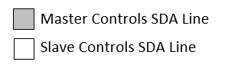To write on the I2C bus, the master will send a start condition on the bus with the slave's address, as well as the last bit (the R/W bit) set to 0, which signifies a write. After the slave sends the acknowledge bit, the master will then send the register address of the register it wishes to write to. The slave will acknowledge again, letting the master know it is ready. After this, the master will start sending the register data to the slave, until the master has sent all the data it needs to (sometimes this is only a single byte), and the master will terminate the transmission with a STOP condition. This is Demonstrated below in the figure.

Writing to slave to I²C bus Process

Reading from Slave in the I²C bus

Reading from a slave is very similar to writing, but with some extra steps. In order to read from a slave, the master must first instruct the slave which register it wishes to read from. This is done by the master starting off the transmission in a similar fashion as the write, by sending the address with the R/W bit equal to 0 (signifying a write), followed by the register address it wishes to read from. Once the slave acknowledges this register address, the master will send a START condition again, followed by the slave address with the R/W bit set to 1 (signifying a read). This time, the slave will acknowledge the read request, and the master releases the SDA bus, but will continue supplying the clock to the slave. During this part of the transaction, the master will become the master-receiver, and the slave will become the slave-transmitter.

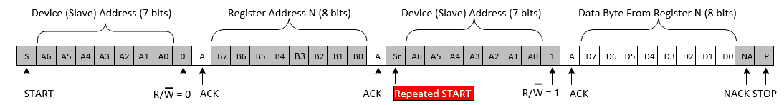The master will continue sending out the clock pulses, but will release the SDA line, so that the slave can transmit data. At the end of every byte of data, the master will send an ACK to the slave, letting the slave know that it is ready for more data. Once the master has received the number of bytes it is expecting, it will send a NACK, signaling to the slave to halt communications and release the bus. The master will follow this up with a STOP condition. Demonstrated in the Figure below

Reading a byte of data in the slave register Process

To do:

UART Communication Annex

Bluetooth Communication

TO DO :

Bibliographie

Texas instruments, Understanding the I2C bus

A.Cirillo, P. Cirillo, G. De Maria, C. Natale, and S. Pirozzi. A comparison of multisensor attitude estimation algorithms. Multisensor Attitude Estimation

Magnetometer basics for mobile phone applications YONGYAO CAI, YANG ZHAO, XIANFENG